- Project Name
Asphalt Surfacing of D3308 and D3287 from Eldorado Village to the D1589

- Project Type
Upgrading of road infrastructure

- Project Location
The project is located in Eldorado, a village in Blouberg Local Municipality within the jurisdiction of Capricorn District Municipality.

- Broader Context
The Phase 1 of the Compilation of the Rural Transport Plan for the Limpopo Province made the following findings with regard to rural transportation in Eldorado.

- Village Profile: The average household size is 5.2 persons per household, with children (56%) being the majority of members. The amount of extended family members and mothers is also significant, with 20% and 15% respectively. Fathers only account for 9% in each household.

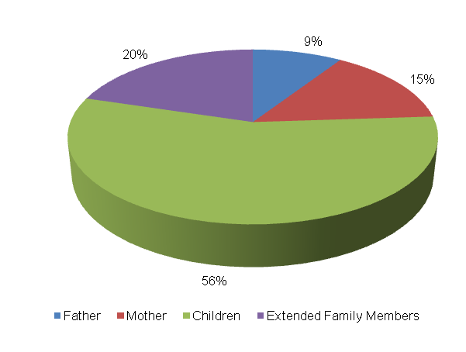

The level of vehicle ownership per household is presented in the table below.

Bicycle | Motor-Bike | Car | Truck Light | Truck Heavy | Tractor | Taxi | Animal-Drawn | Horse/Donkey | Wheel Barrow/ Hand-Held
16 | 1 | 20 | 2 | 2 | 1 | 2 | 7 | 12 | 83
11% | 1% | 14% | 1% | 1% | 1% | 1% | 5% | 8% | 57%

A majority of the households (57%) own a wheel barrow, whilst 14% and 11% of the households in Eldorado own cars and bicycles respectively. 8% own horses whilst 5% own animal drawn carts. The least owned vehicle types by households are motorbikes, light trucks, heavy trucks, tractors and taxis whereby each mode account for only 1% of the households.

The abstract below shows employment status in Eldorado. The following observations were made:
- The unemployment rate is 37%;
- Approximately 36% of people in Eldorado are school going children, with 1% being pre-school going children;
- About 14% of the persons in Eldorado are permanently employed whilst 12% have conditional employment;
- About 1% of the persons in Eldorado are pensioners.

- Travelling Patterns: This section presents the travelling patterns in Eldorado.

- Educational Trips: Majority of the trips are undertaken by foot (90%). An insignificant number of scholars make use of public bus service (2%), cars (2%) and bicycles (2%) to travel to school. Other least used modes to school are lifts (1%); public bakkies (1%) as well as public taxis.

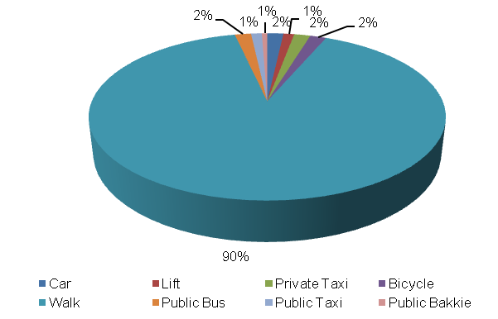

- Work Trips: Majority of work trips are undertaken by private taxis (32%). Other significant work trips are undertaken by foot (23%), public bus service (21%), public taxi (9%) and bicycles (6%). The least number of work trips are made by cars (2%), trains (2%) and lifts (2%).

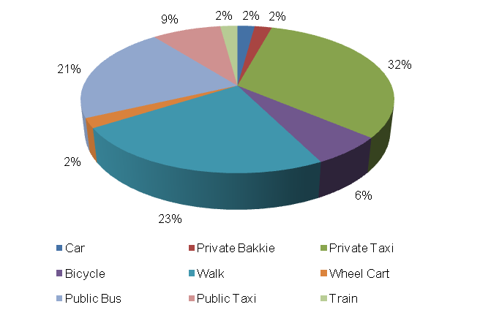

- Other Household Week Travelling: 34% of other members of the households use public bus service to travel to their destination during the week. Other significant modes used for weekday travel include walking (21%), public taxi (17%), lifts (10%), private taxis (7%) as well as cars (7%). An insignificant number of household members use train (3%) for weekly travel.

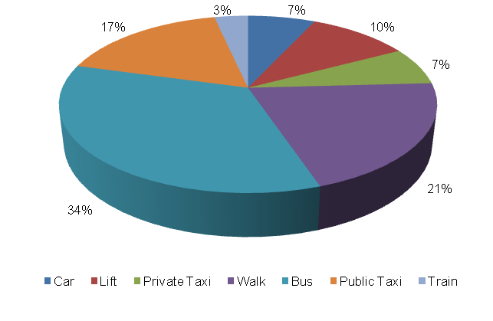

- Household Weekend Travelling: There was no response for weekend travel from the surveyed households in Eldorado.

- Mode Preference
The next section discusses mode preference of different travellers in Eldorado.

- Educational Travel: The majority of scholars prefer to walk to school (54%). Other preferred modes to travel to school include private taxis (26%) and private bakkies (13%). An insignificant number of scholars prefer bicycles (2%), cars (1%) as well as private bakkies (1%).

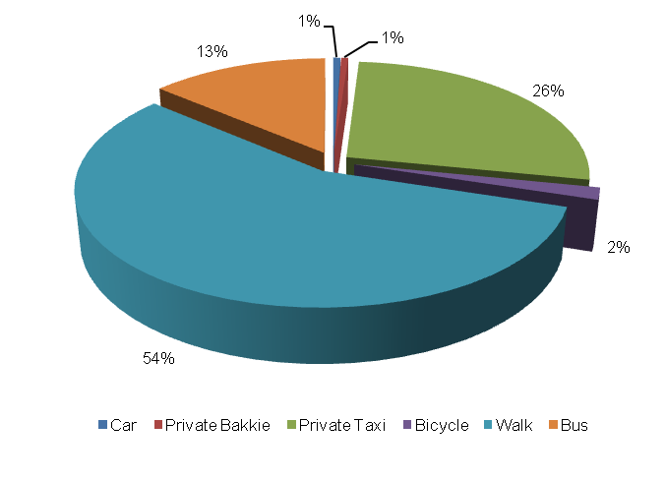
- Work Trips: The majority of income earners prefer to use public taxis to work (45%). Other preferred work modes include private taxis (36%), cars (9%) and lifts (9%).

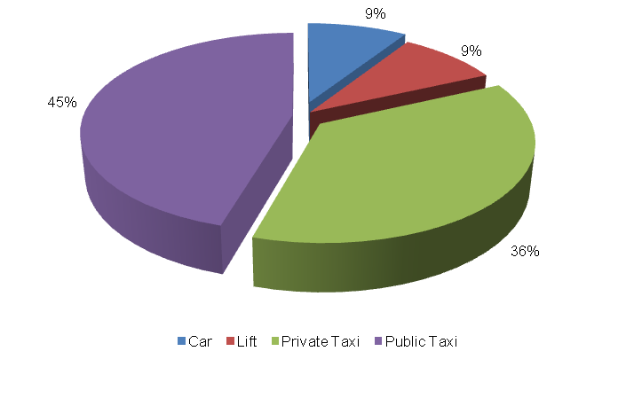
- Identified Transport Usage
The next section presents the usage of transport in Eldorado.

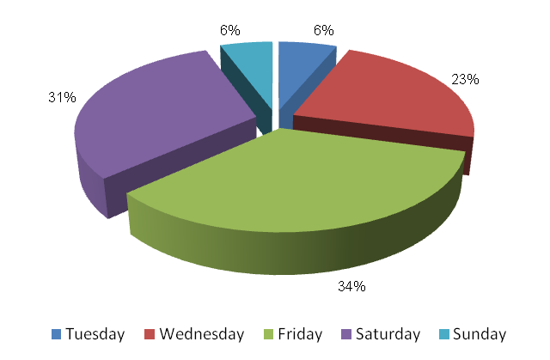

The Eldorado community wait longer for public transport on Fridays. Saturdays and Wednesdays are also difficult days to travel for the persons of Eldorado. Households travel with ease on Tuesdays and Sundays. The persons of Eldorado do not encounter any travel difficulty on Mondays and Thursdays. The Friday that falls on the end of the month is also a difficult period for travelling. Moreover, Easter, Christmas and public holidays are difficult periods to travel for the Eldorado community.

- Identified Transport Issues
This section provides the transport challenges experienced by the Eldorado community. The transport challenges include:
- Limited public transport services;
- Poor road condition;
- Long waiting periods for public transport and
- Lack of public transport infrastructure like bus ranks.

- Detailed Project Description
The main goal of the project is to design and supervise the construction of D3308 and D3287 from Eldorado Village to the D1589. The objectives of the project will be the following:

- Community consultations
- Status quo investigation of existing transport infra-structure
- Development of concept surfacing solutions/options
- Topographical survey of road reserve
- Preliminary design
- Detailed design and Tender documentation
- Construction of facilities
- Maintenance of facilities post construction

The above steps are outlined in detail below:
  - Community Liaison
Community participation needs to form the backbone of the entire implementation process. The community, as the end users, need to be consulted regarding the preferred solutions from a range of concepts that will arise from the preliminary investigations and concept development stage of the project. There will also be need to liaise with individuals whose property may be affected by the project. The project therefore requires a project steering committee that includes all stakeholders, i.e. the community, ward committees, local municipality, district municipality, etc.

  - Status Quo Investigations
The first task to be undertaken under the project shall be a reconnaissance of the existing D3287 and D3308 to Eldorado Village. The reconnaissance shall entail condition survey of the roadways together with an assessment of the stormwater tendencies around the infra-structure.

  - Planning and Development of Concept Solutions
Emanating from the results of the above stage, together with any other areas explored as directed by consultation with the community, a number of concepts shall be developed that would be presented to all stakeholders to select the option that would satisfy all. The basic option shall be taken as the tarring of the roads from the D1589 into the heart of Eldorado. The assumed length of the road is 18 km up to the D1589. Various other possibilities will also be explored.
In conjunction with the development of concepts the municipality, Road Agency Limpopo and Limpopo Roads and Transport shall be approached to determine their requirements with regard to the implementation of the project. Some of the salient issues would be the MIG requirements, the reporting requirements and any other aspects that would have to be incorporated into the project plan.
  - Preliminary Design
Subsequent to the selection of the preferred concept a topographical survey of the road reserves needs to be undertaken in order to produce a digital terrain model (DTM) of the areas. A preliminary design needs to also be undertaken to indicate the existing and modified horizontal layout of the routes together with the vertical alignment in order to determine the bulk earthworks that would be involved. The design needs to adhere to the following basic design requirements:
- providing both horizontal and vertical alignments that adhere to the requirements of the Design Manuals i.e. TRH17 and the Red Book;
- exploration of innovative solutions;
- ensuring that required drainage structures can be accommodated by the proposed alignments;

Preliminary design needs to be concluded by the prepared and submitted of a Preliminary Design Report to the Employer for approval.
  - Detailed Design and Documentation
The purpose of detailed design is to optimize the horizontal and vertical alignments and also address stormwater drainage of the proposed infrastructure. Pavement design should be undertaken in accordance with TRH14. In this stage borrow pits need to be identified, explored and tested if required in order to raise the existing low road levels. All relevant mining permits and environmental impact applications should also be undertaken at this stage. A design report needs to be submitted which should include drawings and updated cost estimates. This stage should culminate with the compilation of tender documents and advertising of the project for contractors to tender.
The tender process and tender evaluation would follow and the preferred Contractor would be recommended for the Employer to appoint. Contract Documents would be compiled that would govern the contract.

  - Construction
Construction of the works would aim to create as much employment as possible for the local community. It would therefore be desirable that the works is undertaken under Labour Intensive Construction mode. The Contractor would submit a construction programme which he would follow in implementing the works. Supervision of construction would provide the Employer with an assurance that the works delivered by the Contractor comply with the requirements set out in the Contract Documents to ensure return on investment. he construction stage would culminate with the handing over of the finished facilities to the community for use. A project close out report would be submitted to outline all achievements and challenges experienced in the project.

  - Transport Infrastructure Maintenance
The maintenance of the transport infrastructure envisaged in Eldorado will be crucial for the provision of proficient and valuable public transport in the settlement. During Phase 3 an Evaluation and Monitoring System will be developed to ensure effective management of transport infrastructure in the settlement.

- Value-Add of the Project to the Community
The following constitute the value added by the project to Eldorado Community:
- Provision of adequate road transport facilities;
- Promote the use of non-motorised transport by providing adequate walkway on the access road;
- Minimise conflict between pedestrians and vehicles;
- Reduce accidents involving pedestrians and vehicles.

- First-Order Cost Estimates
The first-order cost estimate (VAT excluded) for each component of the project is as follows:
- Community liaison (included in the following components)
- Preliminary Investigations and Surveys R 250, 000
- Planning, Design & Tender Documentation R 600, 000
- Construction Contract R 129, 000, 000
- Construction Supervision R 25, 800, 000
- Other: EIA, OHS R 550, 000
The total first-order cost estimate is R 156 200 000
It should be noted that the above costing assumes that essential corrective earthworks would be applied to the road prior to surfacing. Furthermore, possible sources of funding for this project would be MIG funding from the municipality which would require that the project is listed in their IDP. Other funding can be sourced from the EPWP budget if the project is packaged for that mode of construction.
- Project Duration
The following timeframes are envisaged per component:
- Planning, Design & Tender Documentation 7 months
- Construction Contract 18 months

- First-Order Risk Assessment
The only first-order risks identified is the availability of MIG funding for the projects.

- Opportunity for SMME Involvement
SMME can be offered sub-contracts on portions of the works.

