- Project Name
Asphalt Surfacing of D4050 from Kappa to Mashushu

- Project Type
This type of project is categorised as an Upgrading of Road Project.

- Project Location
The project is located in Mafefe Village found in the Lepelle-Nkumpi Local Municipality in Capricorn District Municipality

- Broader Context
The project is derived from the findings of the Limpopo Rural Strategy Status Quo Report which identified transportation gaps within the province. Phase 1 of the Limpopo Rural Transport Strategy made the following findings with regard to rural transportation in Mafefe:

- Village Profile: the average household size in Mafefe is 6 persons per household, with children (68%) being the majority of the household members. The amount of mothers and fathers is also significant, with 16% and 10 percent respectively. Extended family members only account for 8% in each household.

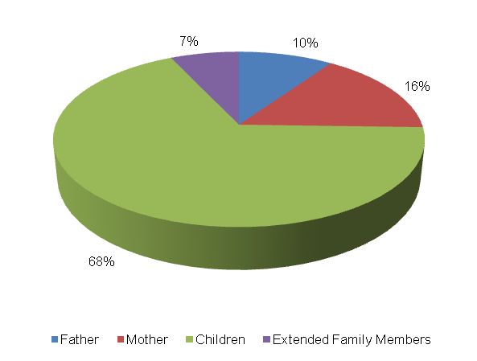

The level of vehicle ownership per household is presented in the table below. A majority of the households (66%) own a wheel barrow, whilst 9% and 8 percent of the households in Mafefe own bicycles and cars respectively. 7 percent own animal drawn carts whilst 6% own horses. The least owned vehicle types by households are heavy trucks and tractors which both account for only 1% of the households.

Bicycle | Motor-bike | Car | Truck Light | Truck Heavy | Tractor | Taxi | Animal-Drawn | Horse/  Donkey | Wheel Barrow/ Handheld
10 | 1 | 9 | 0 | 1 | 1 | 0 | 8 | 7 | 71
9% | 1% | 8% | 0% | 1% | 1% | 0% | 7% | 6% | 66%

The abstract below shows employment status in Mafefe. The following observations are made:
- The unemployment rate is 37 percent;
- Approximately 50 percent of people in Mafefe are school going children, with 4 percent being pre-school going children;
- Approximately 4 percent of the persons in Mafefe are permanently employed furthermore another 4 percent is conditionally employed.

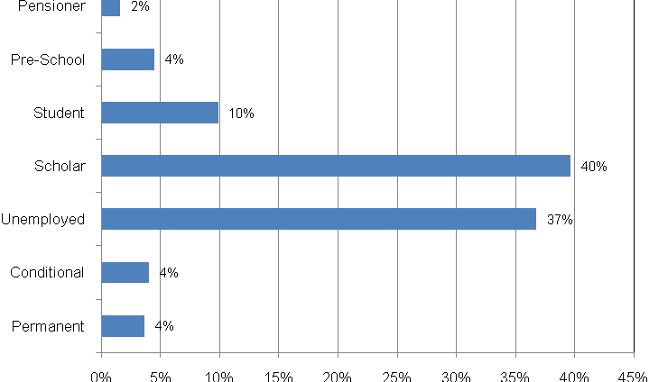

- Travelling Patterns: this section presents the travelling patterns in Mafefe per trip purpose.

- Educational Trips: Majority of the trips are undertaken by foot (80%). Other significant educational trips are undertaken by public bus service (12%) as well as lifts (4%). An insignificant number of scholars make use of private bakkies (2%), private taxis (2%) as well as cars (1%) to travel to school. 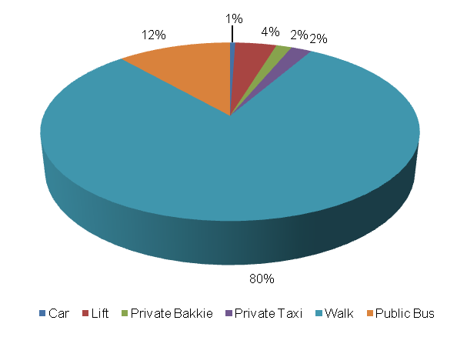
- Work Trips: Majority of work trips are undertaken by public bus service (37%). Other significant work trips are undertaken by foot (29%) and public taxi (19%). The least number of work trips are made by cars (8%) and private taxis (8%).

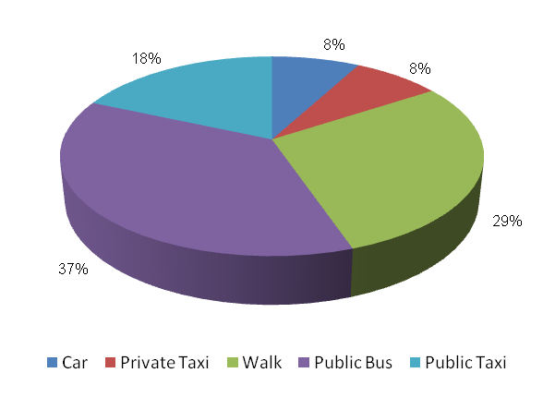
- Other Household Week Travelling: 56 percent of other members of the households walk to their destinations during the week. Other modes which were widely used for weekday travel include public bus service (32%), lifts (4%) and private taxis (4%). An insignificant number of household members use cars (1%), wheel cart (1%), donkey cart (1%), private bakkie (1%) and public taxi (1%).

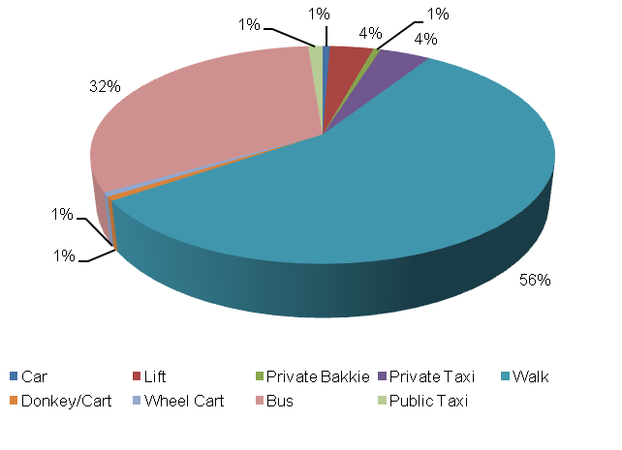
- Household Weekend Travelling: 58 percent of household members walk to their destinations during the weekend. Other significant modes of transport used for weekend travel include public bus service (22%), private taxis (8%) and lifts (4%). The least number of households use public taxis (3%), private bakkies (2%) and public bakkies (1%) for weekend travel.

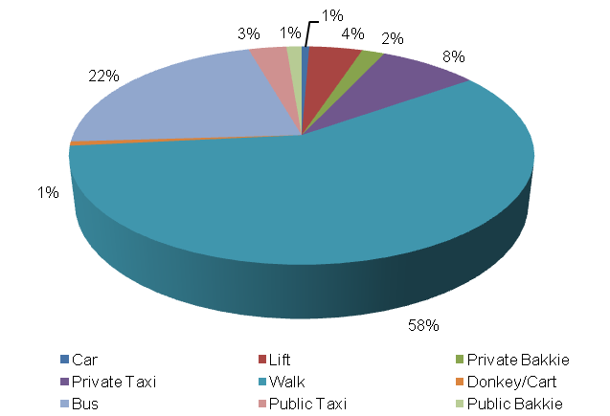

- Mode preference
The next section discusses mode preference of different travellers in Mafefe by trip purpose:

- Educational Travel: The majority of scholars prefer to use a public bus service to school (78%). Other preferred modes to travel to school include walking (7%), private taxis (7%) and bicycles (6%). An insignificant number of scholars prefer public taxis (2%) and cars (1%).

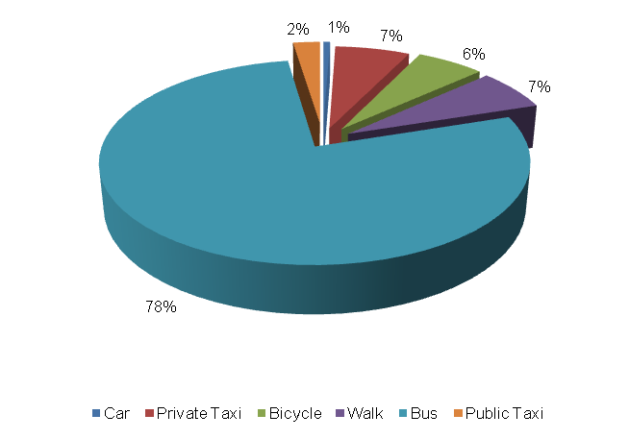

- Work Trips: The majority of income earners prefer to walk to work (33%). Other preferred work modes include public bus service (22%), cars (11%), private bakkies (11%), private taxis (11%) as well as bicycles (11%).

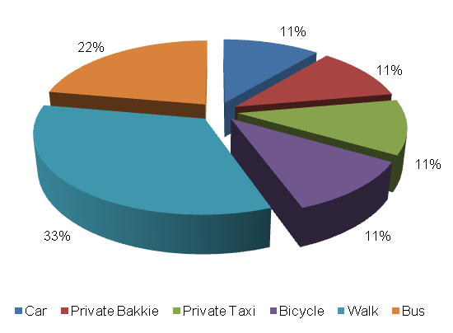

- Identified Transport Usage Gaps
Mafefe community wait longer for public transport on Mondays. Friday is also a difficult day to travel for the persons of Mafefe. Households indicated that they travel with ease on Wednesdays and Thursdays. The residents of Mafefe do not encounter any travel hindrances on Tuesdays, Saturdays and Sundays. Fridays that falls on the end of the month is also a difficult period for travelling. Furthermore, public holidays, Christmas and Easter are difficult periods to travel for the Mafefe community.

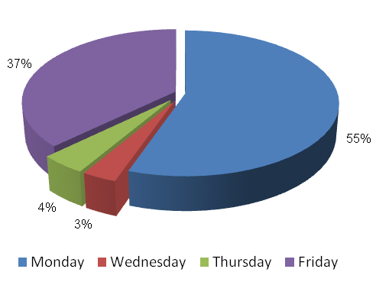

- Identified Transport Issues
Community in Mafefe Village experience the following transport challenges:
- Limited public transport services;
- Poor road condition;
- Long waiting periods for public transport;
- Lack of public transport infrastructure like bus rank.

- Detailed Project Description
The main goal of the project is to surface the D4050, with allowance for NMT infrastructure, from Kappa settlement to Mashushu to address the needs of the community at large
The objectives of the project will be the following:
- Community consultations
- Status quo investigation of existing transport infra-structure
- Development of concept surfacing solutions/options
- Topographical survey of road reserve
- Preliminary design
- Detailed design and Tender documentation
- Construction of facilities
- Maintenance of facilities post construction

The above steps are outlined in detail below:
  - Community Liaison
Community participation needs to form the backbone of the entire implementation process. The community, as the end users, need to be consulted regarding the preferred solutions from a range of concepts that will arise from the preliminary investigations and concept development stage of the project. There will also be need to liaise with individuals whose property may be affected by the project. The project therefore requires a project steering committee that includes all stakeholders, i.e. the community, ward committees, local municipality, district municipality, etc.

  - Status Quo Investigations
The first task to be undertaken under the project shall be a reconnaissance of the existing road from Mashushu to Kappa settlements. The reconnaissance shall entail condition survey of the roadways together with an assessment of the stormwater tendencies around the infra-structure.

  - Planning and Development of Concept Solutions
Emanating from the results of the above stage, together with any other areas explored as directed by consultation with the community, a number of concepts need to be developed for presentation to all stakeholders to select the option that would satisfy all. The basic option shall be taken as the tarring of the D4050 from Mashushu to Kappa, with the assumed length of the road being 12km. Various other possibilities will also be explored.
In conjunction with the development of concepts the municipality, Road Agency Limpopo and Limpopo Roads and Transport shall be approached to determine their requirements with regard to the implementation of the project. Some of the salient issues would be the MIG requirements, the reporting requirements and any other aspects that would have to be incorporated into the project plan.

  - Preliminary Design
Subsequent to the selection of the preferred concept a topographical survey of the road reserves needs to be undertaken in order to produce a digital terrain model (DTM) of the areas. A preliminary design needs to also be undertaken to indicate the existing and modified horizontal layout of the routes together with the vertical alignment in order to determine the bulk earthworks that would be involved. The design needs to adhere to the following basic design requirements:
- providing both horizontal and vertical alignments that adhere to the requirements of the Design Manuals i.e. TRH17 and the Red Book;
- exploration of innovative solutions;
- ensuring that required drainage structures can be accommodated by the proposed alignments;

Preliminary design needs to be concluded by the prepared and submitted of a Preliminary Design Report to the Employer for approval.

  - Detailed Design and Documentation
The purpose of detailed design is to optimize the horizontal and vertical alignments and also address stormwater drainage of the proposed infrastructure. Pavement design should be undertaken in accordance with TRH14. In this stage borrow pits need to be identified, explored and tested if required in order to raise the existing low road levels. All relevant mining permits and environmental impact applications should also be undertaken at this stage. A design report needs to be submitted which should include drawings and updated cost estimates. This stage should culminate with the compilation of tender documents and advertising of the project for contractors to tender.
The tender process and tender evaluation would follow and the preferred Contractor would be recommended for the Employer to appoint. Contract Documents would be compiled that would govern the contract.

  - Construction
Construction of the works would aim to create as much employment as possible for the local community. It would therefore be desirable that the works is undertaken under Labour Intensive Construction mode. The Contractor would submit a construction programme which he would follow in implementing the works. Supervision of construction would provide the Employer with an assurance that the works delivered by the Contractor comply with the requirements set out in the Contract Documents to ensure return on investment. he construction stage would culminate with the handing over of the finished facilities to the community for use. A project close out report would be submitted to outline all achievements and challenges experienced in the project.

  - Transport Infrastructure Maintenance
The maintenance of the transport infrastructure envisaged in Lepelle-Nkumpi will be crucial for the provision of proficient and valuable public transport in the settlement. During Phase 3 an Evaluation and Monitoring System will be developed to ensure effective management of transport infrastructure in the settlement.
- Value-Add of the Project to the Community
The following constitute the value added by the project to Lepelle-Nkumpi Community:
- Provision of adequate road transport facilities;
- Promote the use of non-motorised transport by providing adequate walkway on the access road;
- Minimise conflict between pedestrians and vehicles;
- Reduce accidents involving pedestrians and vehicles.

- First-Order Cost Estimates
The first-order cost estimate (VAT excluded) for each component of the project is as follows:
- Community liaison (included in the following components)
- Preliminary Investigations and Surveys R 250, 000
- Planning, Design & Tender Documentation R 600, 000
- Construction Contract R 72, 000, 000
- Construction Supervision R 14, 400, 000
- Other: EIA, OHS R 550, 000
The total first-order cost estimate is R 87 800, 000.
It should be noted that the above costing assumes that essential corrective earthworks would be applied to the road prior to surfacing. Furthermore, possible sources of funding for this project would be MIG funding from the municipality which would require that the project is listed in their IDP. Other funding can be sourced from the EPWP budget if the project is packaged for that mode of construction.
- Project Duration
The following timeframes are envisaged per component:
- Planning, Design & Tender Documentation 7 months
- Construction Contract 12 months

- First-Order Risk Assessment
The only first-order risks identified is the availability of MIG funding for the projects.

- Opportunity for SMME Involvement
SMME can be offered sub-contracts on portions of the works.

