- Project Name
Asphalt Surfacing of the provincial road D11 from Lemondokop Village to R81

- Project Type
The project is classified as an Upgrading of Road Infrastructure Project

- Project Location
The project is located in Lemondokop, a village in Letaba Local Municipality within the jurisdiction of Mopani District Municipality.

- Broader Context
This project emanates from the Limpopo Rural Strategy status quo findings whereby a need for the project was identified. The Phase 1 of the Compilation of the Rural Transport Plan for the Limpopo Province made the following findings with regard to rural transportation in Lemondokop.

- Village Profile
The average household size is 7 persons per household, with children (52%) being the majority of members. The amount of extended family members and mothers is also significant, with 26 percent and 14 percent respectively. Fathers account for 8 percent per household.

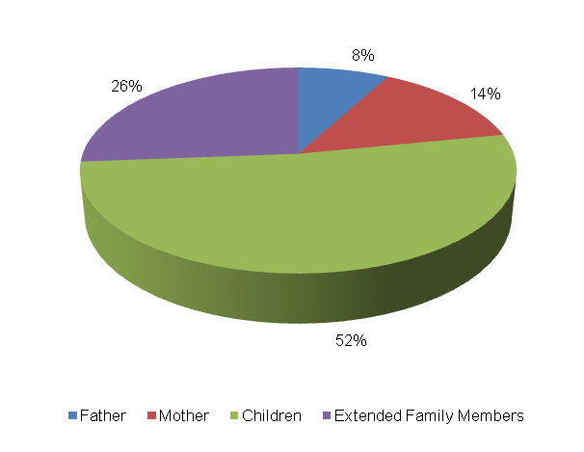

The level of vehicle ownership per household is presented in the table below.

Bicycle | Motor-bike | Car | Truck (light) | Truck (heavy) | Tractor | Taxi | Animal-drawn cart | Horse/ donkey | Wheelbarrow/ Hand-held cart | Others | Total
8 | 1 | 49 | 1 | 0 | 6 | 0 | 0 | 0 | 67 | 1 | 133
6% | 1% | 37% | 1% | 0% | 5% | 0% | 0% | 0% | 50% | 1%

A majority of the households (50%) own a wheel barrow, whilst 37 percent own cars, 6 percent bicycles and 5 percent of the households in Lemondokop own tractors. The least owned vehicle types by households are light trucks (1%) and motorbikes (1%).

The abstract below shows employment status in Lemondokop. The following observations were made:
- Approximately 35 percent of the persons in Lemondokop unemployed;
- Approximately 46 percent of the persons in Lemondokop are school going children, with 5 percent being pre-school going children;
- About 5 percent of the persons in Lemondokop are permanently employed whilst 6% are conditionally employed;
- About 2 percent of the persons in Lemondokop are pensioners.

- Travelling Patterns
This section presents the travelling patterns in Lemondokop.

- Educational Trips
All educational trips were undertaken by foot (100%).

- Work Trips
Majority of work trips are undertaken by cars (27%) and foot (27%). Other significant work trips are undertaken by private taxi (18%), public bakkie (9%), public taxi (9%) and private bakkie (9%).

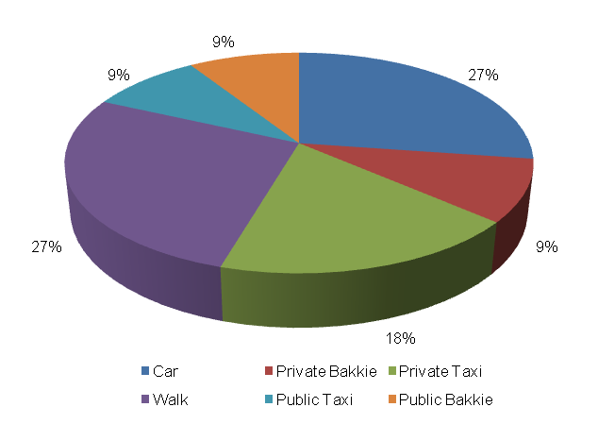
- Other Household Week Travelling
60% of other members of the households used cars to travel to their destination during the week. Other significant modes used for weekday travel include walking (20%) and public bakkie (20%).
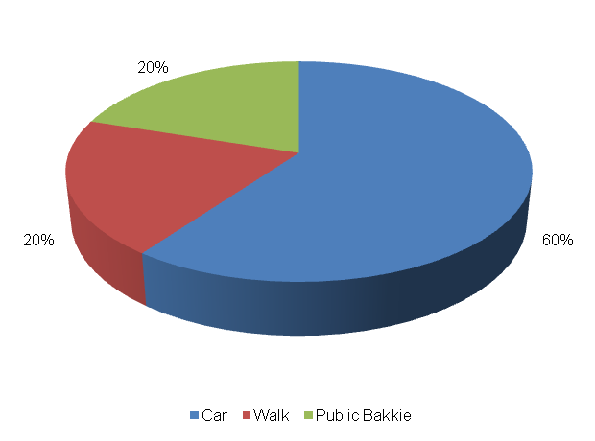

- Household Weekend Travelling
Majority of household members travelled by foot (75%) to their destinations during the weekend. Other significant modes of transport used for weekend travel include the private taxi with (8%), cars (7%), as well as public taxis (5%). The least modes used for weekend trips include private bakkies (2%), lifts (1%) and public bakkies (1%).

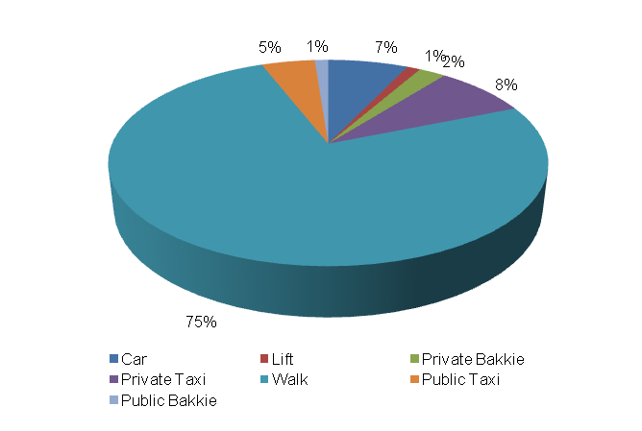
- Mode preference
The next section discusses mode preference of different travellers in Lemondokop.
- Educational Travel
The majority of scholars prefer to walk to school (50%). Other preferred modes for school trips include cars (13%) and wheel carts (13%).

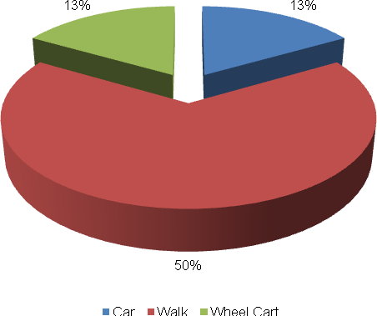
- Work Trips
The majority of workers prefer to use cars to travel to work (45%). Other preferred work modes include private taxis (18%), lifts (9%), private bakkies (9%), public bakkies (9%) as well as walking (9%).

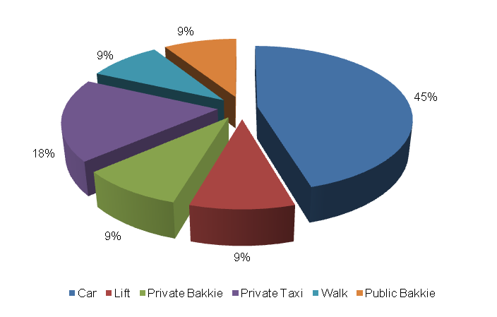
- Identified Transport Usage
The next section presents the usage of transport in Lemondokop.

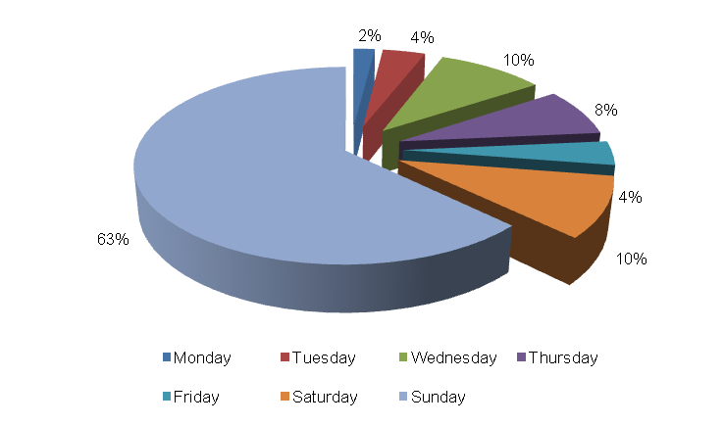
The Lemondokop community wait longer for public transport on Sundays. Wednesdays, Thursdays and Saturdays are also difficult days to travel for the persons of Lemondokop. The persons of Lemondokop travel with ease on Mondays, Tuesdays and Fridays. The Friday and Saturday that falls on the end of the month are also a difficult periods for travelling. Moreover, Public Holidays, Christmas and Easter, are difficult periods to travel for the Lemondokop residents.

- Identified Transport Issues
This section provides the transport challenges experienced by the Lemondokop community. The transport challenges include (1) limited public transport services; (2) poor road condition; (3) long waiting periods for public transport; (4) lack of road signs; (5) Lack of non motorised infrastructure (NMT) and (6) lack of public transport infrastructure like bus ranks.

- Detailed Project Description
The main goal of the project is to surface the D11, with NMT infrastructure, from the R81 to the settlement to address the needs of the community at large for approximately 30km.
The objectives of the project will be the following:
- Community consultations
- Status quo investigation of existing transport infra-structure
- Development of concept surfacing solutions/options
- Topographical survey of road reserve
- Preliminary design
- Detailed design and Tender documentation
- Construction of facilities
- Maintenance of facilities post construction

The above steps are outlined in detail below:
  - Community Liaison
Community participation needs to form the backbone of the entire implementation process. The community, as the end users, need to be consulted regarding the preferred solutions from a range of concepts that will arise from the preliminary investigations and concept development stage of the project. There will also be need to liaise with individuals whose property may be affected by the project. The project therefore requires a project steering committee that includes all stakeholders, i.e. the community, ward committees, local municipality, district municipality, etc.

  - Status Quo Investigations
The first task to be undertaken under the project shall be a reconnaissance of the existing D11 road to Lemondokop Village. The reconnaissance shall entail condition survey of the roadways together with an assessment of the stormwater tendencies around the infra-structure.

  - Planning and Development of Concept Solutions
Emanating from the results of the above stage, together with any other areas explored as directed by consultation with the community, a number of concepts shall be developed that would be presented to all stakeholders to select the option that would satisfy all. The basic option shall be taken as the tarring of the road from the R81 into the heart of Lemondokop. The assumed length of the road is 30 km upto the R81. Various other possibilities will also be explored.
In conjunction with the development of concepts the municipality, Road Agency Limpopo and Limpopo Roads and Transport should be approached to determine their requirements with regard to the implementation of the project. Some of the salient issues would be the MIG requirements, the reporting requirements and any other aspects that would have to be incorporated into the project plan.
  - Preliminary Design
Subsequent to the selection of the preferred concept a topographical survey of the road reserves needs to be undertaken in order to produce a digital terrain model (DTM) of the areas. A preliminary design needs to also be undertaken to indicate the existing and modified horizontal layout of the routes together with the vertical alignment in order to determine the bulk earthworks that would be involved. The design needs to adhere to the following basic design requirements:
- providing both horizontal and vertical alignments that adhere to the requirements of the Design Manuals i.e. TRH17 and the Red Book;
- exploration of innovative solutions;
- ensuring that required drainage structures can be accommodated by the proposed alignments;

Preliminary design needs to be concluded by the prepared and submitted of a Preliminary Design Report to the Employer for approval.
  - Detailed Design and Documentation
The purpose of detailed design is to optimize the horizontal and vertical alignments and also address stormwater drainage of the proposed infrastructure. Pavement design should be undertaken in accordance with TRH14. In this stage borrow pits need to be identified, explored and tested if required in order to raise the existing low road levels. All relevant mining permits and environmental impact applications should also be undertaken at this stage. A design report needs to be submitted which should include drawings and updated cost estimates. This stage should culminate with the compilation of tender documents and advertising of the project for contractors to tender.
The tender process and tender evaluation would follow and the preferred Contractor would be recommended for the Employer to appoint. Contract Documents would be compiled that would govern the contract.

  - Construction
Construction of the works would aim to create as much employment as possible for the local community. It would therefore be desirable that the works is undertaken under Labour Intensive Construction mode. The Contractor would submit a construction programme which he would follow in implementing the works. Supervision of construction would provide the Employer with an assurance that the works delivered by the Contractor comply with the requirements set out in the Contract Documents to ensure return on investment. he construction stage would culminate with the handing over of the finished facilities to the community for use. A project close out report would be submitted to outline all achievements and challenges experienced in the project.

  - Transport Infrastructure Maintenance
The maintenance of the transport infrastructure envisaged in Lemodokop will be crucial for the provision of proficient and valuable public transport in the settlement. During Phase 3 an Evaluation and Monitoring System will be developed to ensure effective management of transport infrastructure in the settlement.

- Value-Add of the Project to the Community
The following constitute the value added by the project to Lemondokop Community:
- Provision of adequate road transport facilities;
- Promote the use of non-motorised transport by providing adequate walkway on the access road;
- Minimise conflict between pedestrians and vehicles;
- Reduce accidents involving pedestrians and vehicles.

- First-Order Cost Estimates
The first-order cost estimate (VAT excluded) for each component of the project is as follows:
- Community liaison (included in the following components)
- Preliminary Investigations and Surveys R 250, 000
- Planning, Design & Tender Documentation R 600, 000
- Construction Contract R 180,000, 000
- Construction Supervision R 36, 000, 000
- Other: EIA, OHS R 550, 000
The total first-order cost estimate is R 217 400 000
It should be noted that the above costing assumes that essential corrective earthworks would be applied to the road prior to surfacing. Furthermore, possible sources of funding for this project would be MIG funding from the municipality which would require that the project is listed in their IDP. Other funding can be sourced from the EPWP budget if the project is packaged for that mode of construction.
- Project Duration
The following timeframes are envisaged per component:
- Planning, Design & Tender Documentation 7 months
- Construction Contract 18 months

- First-Order Risk Assessment
The only first-order risks identified is the availability of MIG funding for the projects.

- Opportunity for SMME Involvement
SMME can be offered sub-contracts on portions of the works.

