- Project Name
The Provision of Public Transport and Road Infrastructure for the Leolo Mountain Village Community

- Project Type
Upgrading of Road Infrastructure and Provision of Public Transport Infrastructure

- Project Location
The project is located in Leolo, a village in Makhudithamaga Local Municipality within the jurisdiction of Sekhukhune District Municipality

- Broader Context
This project emanated from the Limpopo Rural Strategy status quo findings whereby a need for the project was identified.

Phase 1 of the Compilation of the Rural Transport Plan for the Limpopo Province made the following findings with regard to rural transport in Leolo Moela.

- Village Profile: The average household in Leolo Moela comprises of 8 members, with children accounting for almost half of the members within a household (52%).The amount of extended family members is also significant with 30%. Fathers and Mothers account for 7% and 12% respectively.
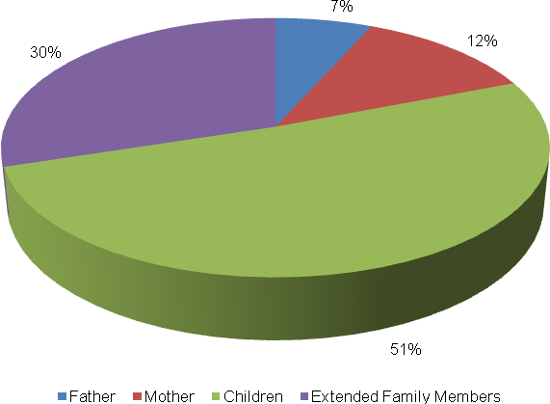
The level of vehicle ownership per household in Leolo Moela is presented in the table below.
Bicycle | Motorbike | Car | Truck (light) | Truck (heavy) | Tractor | Taxi | Animal-drawn cart | Horse/ donkey | Wheelbarrow/ Hand-held cart
7 | 5 | 28 | 1 | 2 | 5 | 2 | 2 | 24 | 69
5% | 3% | 19% | 1% | 1% | 3% | 1% | 1% | 17% | 48%

Almost half of the households own wheelbarrows or handheld carts (48%), followed by those who own cars (11%). Other households own horses or donkeys (17%), bicycles (5%), motorbikes (3%) and tractors (3%). Amongst the least owned vehicle types are light trucks (1%), heavy trucks (1%) and taxis (1%).
The following observations regarding Leolo Moela’s employment status were made from the illustration below:

  - Approximately 31 percent of persons in Leolo Moela are unemployed, whilst 8 are employed on a conditional basis and 5% are permanently employed;
  - 3 percent of persons in Leolo Meola are pensioners whereas another 3% are housewives;
  - Only 1 percent of persons in Leolo Moela are self-employed;
  - Approximately 41 percent of persons are school-going children, with 9 percent comprising of pre-schoolers; and
  - Only 8 percent are post-high school students.

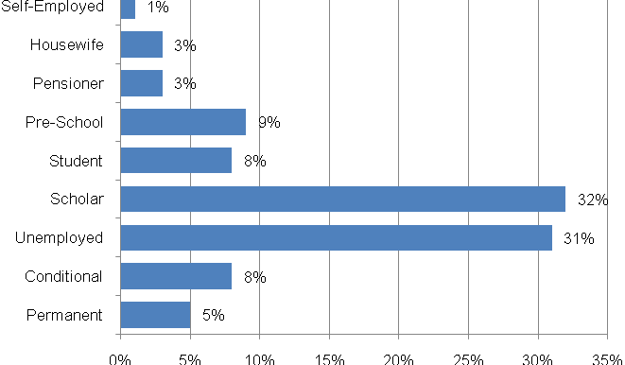

- Travelling Patterns
This section presents the travelling patterns in Leolo Moela.

  - Educational Trips
The majority of educational trips are undertaken on foot (98%) whilst others are by private taxi (1%) and Shova-Kalula (1%).

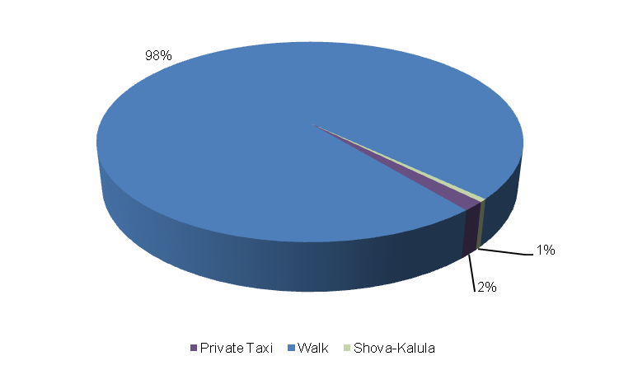
  - Work Trips: 40 percent of income-earners walk to work, whilst 29 percent take lifts, 23 percent use public taxis and 5 percent make use of private taxis. Other modes used for work trips are cars public buses (2%), cars (1%) and private bakkies (1%).

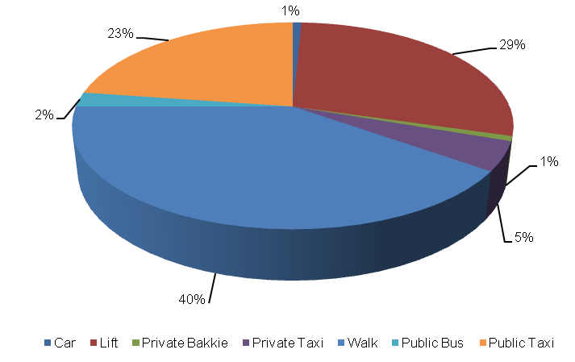
  - Other Household Week Travelling: Other household week trips are undertaken on foot (40%) followed by those that make use of lifts (29%). Another significant modes of transport used are public taxis (23%). Among the least used transport modes are private taxis (5%) and buses (2%).
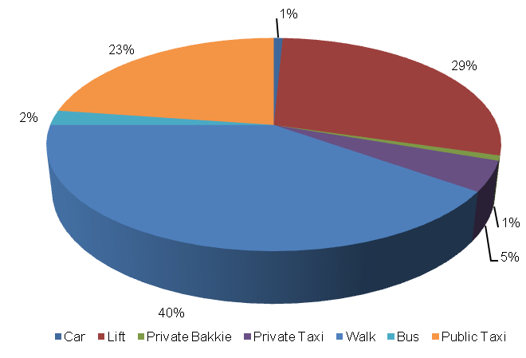

  - Household Weekend Travelling: 51% of household members walk to their destinations during weekends. Others make use of lifts (24%), bicycles (17%) and private taxis (6%). Public bakkies are the least used for weekend trips (1%).
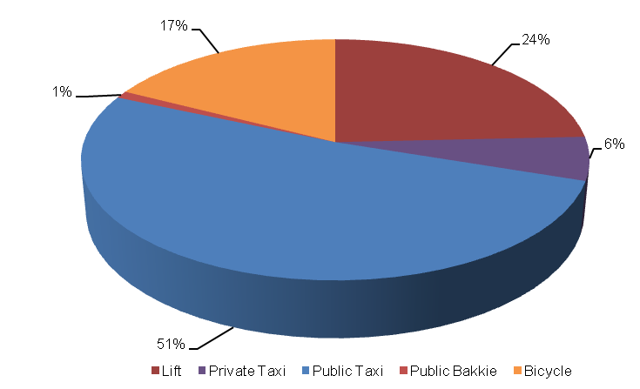
- Mode Preference
The next section discusses mode preference of different travellers in Leolo Moela.

  - Educational Travel: Approximately 38% of travellers in Leolo Moela prefer taking donkey cart rides to school and 33% prefer to travel on foot. Other travellers prefer undertaking educational trips by means of bicycles (9%) with others having a reference of trains over any other means of travelling (8%). Among the least preferred modes of transport for educational trips are motorcycles (3%), private taxis (2%), wheel carts (2%), lifts (1%) and cars (1%).
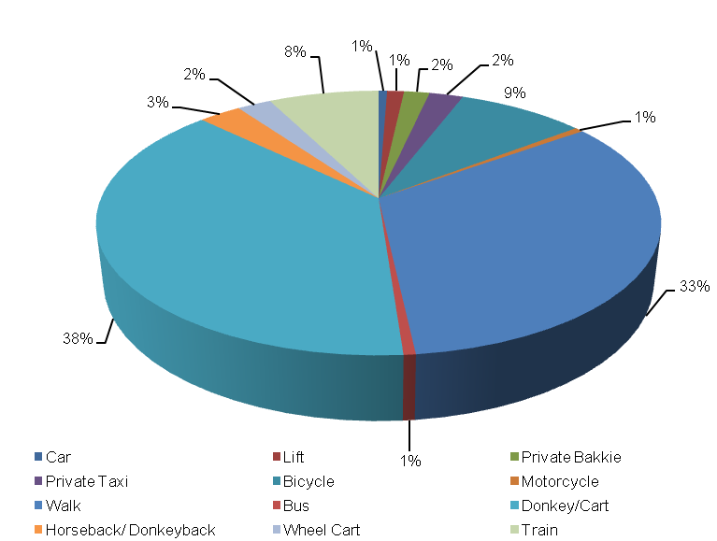

  - Work Trips: The majority of income earners prefer using donkey carts as a means of transport to their workplaces (38%) whilst other prefer travelling on foot (33%). Other preferred work modes include the use of bicycles (9%), the train (8%) and horse/donkey back rides (3%). Amongst the more insignificant travel modes preferred by income earners are wheel carts (2%), private taxis (2%), private bakkies (2%) and cars (1%).

- Identified Transport Issues
Some of the transport challenges experienced by the Leolo Moela community include the following: (1) limited public transport; (2) high transport costs; (3) long waiting periods for public transport and (4) poor road conditions.

- Detailed Project Description
The main goal of the project is to the provision of public transport and road infrastructure for the Leolo Mountain Village to address the needs of the community at large.
The objectives of the project will be the following:
- Community consultations
- Status quo investigation of existing transport infrastructure
- Development of concept surfacing solutions/options
- Topographical survey of road reserve
- Preliminary Design
- Detailed Design and Tender Documentation
- Construction of Public Transport and Road Facilities
- Maintenance of facilities post construction

The above steps are outlined in detail below:
  - Community Liaison
Community participation needs to form the backbone of the entire implementation process. The community, as the end users, need to be consulted regarding the preferred solutions from a range of concepts that will arise from the preliminary investigations and concept development stage of the project. There will also be need to liaise with individuals whose property may be affected by the project. The project therefore requires a project steering committee that includes all stakeholders, i.e. the community, ward committees, local municipality, district municipality, public transport associations, etc.

  - Status Quo Investigations
The first task to be undertaken under the project shall be a reconnaissance of the existing public transport and road infrastructure within Leolo Mountain Village. The reconnaissance shall entail condition survey of the roadways together with an assessment of the stormwater tendencies around the infra-structure.

  - Planning and Development of Concept Solutions
Emanating from the results of the above stage, together with any other areas explored as directed by consultation with the community, a number of concepts shall be developed that would be presented to all stakeholders to select the option that would satisfy all. The basic option shall be taken as the provision of public transport (public transport laybys); Non-Motorised Transport (pedestrian walks) and road infrastructure for Leolo Mountain Village. Various other possibilities will also be explored.
In conjunction with the development of concepts the municipality, Road Agency Limpopo and Limpopo Roads and Transport shall be approached to determine their requirements with regard to the implementation of the project. Some of the salient issues would be the MIG requirements, the reporting requirements and any other aspects that would have to be incorporated into the project plan.

  - Preliminary Design
Subsequent to the selection of the preferred concept a topographical survey of the road reserves needs to be undertaken in order to produce a digital terrain model (DTM) of the areas. A preliminary design needs to also be undertaken to indicate the existing and modified horizontal layout of the routes together with the vertical alignment in order to determine the bulk earthworks that would be involved. The design needs to adhere to the following basic design requirements:
- providing both horizontal and vertical alignments that adhere to the requirements of the Design Manuals i.e. TRH17 and the Red Book;
- exploration of innovative solutions;
- ensuring that required drainage structures can be accommodated by the proposed alignments;

Preliminary design needs to be concluded by the prepared and submitted of a Preliminary Design Report to the Employer for approval.

  - Detailed Design and Documentation
The purpose of detailed design is to optimize the horizontal and vertical alignments and also address stormwater drainage of the proposed infrastructure. Pavement design should be undertaken in accordance with TRH14. In this stage borrow pits need to be identified, explored and tested if required in order to raise the existing low road levels. All relevant mining permits and environmental impact applications should also be undertaken at this stage. A design report needs to be submitted which should include drawings and updated cost estimates. This stage should culminate with the compilation of tender documents and advertising of the project for contractors to tender. The tender process and tender evaluation would follow and the preferred Contractor would be recommended for the Employer to appoint. Contract Documents would be compiled that would govern the contract.

  - Construction
Construction of the works would aim to create as much employment as possible for the local community. It would therefore be desirable that the works is undertaken under Labour Intensive Construction mode. The Contractor would submit a construction programme which he would follow in implementing the works. Supervision of construction would provide the Employer with an assurance that the works delivered by the Contractor comply with the requirements set out in the Contract Documents to ensure return on investment. The construction stage would culminate with the handing over of the finished facilities to the community for use. A project close out report would be submitted to outline all achievements and challenges experienced in the project.

  - Transport Infrastructure Maintenance
The maintenance of the transport infrastructure envisaged in Leolo Mountain will be crucial for the provision of proficient and valuable public transport in the settlement. During Phase 3 an Evaluation and Monitoring System will be developed to ensure effective management of transport infrastructure in the settlement.

- Value-Add of the Project to the Community
The following constitute the value added by the project to Leolo Mountain Community:
- Provision of adequate road transport facilities;
- Promote the use of non-motorised transport by providing adequate walkway on the access road;
- Minimise conflict between pedestrians and vehicles;
- Reduce accidents involving pedestrians and vehicles.

- First-Order Cost Estimates
The first-order cost estimate (VAT excluded) for each component of the project is as follows:
- Community liaison (included in the following components)
- Preliminary Investigations and Surveys R 250, 000
- Planning, Design & Tender Documentation R 600, 000
- Construction Contract R 108, 000, 000
- Construction Supervision R 21, 600, 000
- Other: EIA, OHS R 550, 000
The total first-order cost estimate is R 131 000 000.
It should be noted that the above costing assumes that essential corrective earthworks would be applied to the road prior to surfacing. Furthermore, possible sources of funding for this project would be MIG funding from the municipality which would require that the project is listed in their IDP. Other funding can be sourced from the EPWP budget if the project is packaged for that mode of construction.
- Project Duration
The following timeframes are envisaged per component:
- Planning, Design & Tender Documentation 7 months
- Construction Contract 18 months

- First-Order Risk Assessment
The only first-order risks identified is the availability of MIG funding for the projects.

- Opportunity for SMME Involvement
SMME can be offered sub-contracts on portions of the works.

