- Project Name
Upgrading of D4177 & D4176 from Shakung Village to R37

- Project Type
Upgrading of road infrastructure

- Project Location
The project is located in Shakung village in Tubatse Local Municipality within the jurisdiction of Sekhukhune District Municipality.

- Broader Context
This project emanated from the Limpopo Rural Strategy status quo findings whereby a need for the project was identified.

Phase 1 of the Compilation of the Rural Transport Plan for the Limpopo Province made the following findings with regards to rural transportation in Shakung.

- Village Profile: The average household in Shakung comprises of 7 people with children accounting for the majority of members (58%). Extended family members account for 18 percent of members within a household, whereas mothers and fathers account for 14 percent and 10 percent respectively.
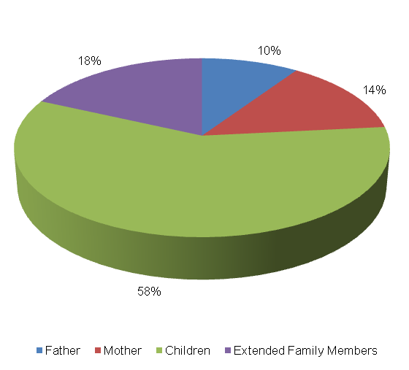

The level of vehicle ownership per household is presented below.
Bicycle | Motor-bike | Car | Truck (light) | Truck (heavy) | Tractor | Taxi | Animal-drawn cart | Horse/ donkey | Wheelbarrow/ Hand-held cart
2 | 0 | 14 | 0 | 0 | 0 | 0 | 0 | 39 | 0
4% | 0% | 25% | 0% | 0% | 0% | 0% | 0% | 71% | 0%

The majority of households in the Shakung settlement own horses or donkeys (71%), whilst 25 percent and 4 percent own cars and bicycles, respectively. None of the households own trucks (heavy or light), motorbikes, tractors, taxis animal-drawn carts or wheelbarrows. The figure below illustrates the employment status in Shakung. The following observations were made:

  - 34 percent of persons residing in Shakung are unemployed;
  - Approximately 39 percent of persons are employed, with 18 percent being employed on a conditional basis and 18 percent being permanently employed; and
  - 26 percent of persons in Shakung are scholars and 1 percent are post-matric students.
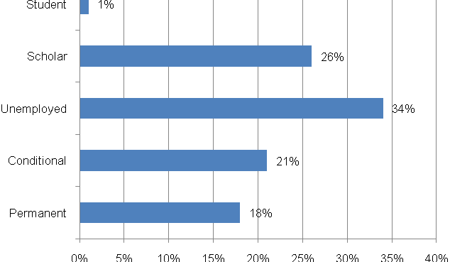

- Travelling Patterns
This section presents travelling patterns in Shakung.

  - Educational Trips: The majority of educational trips are undertaken on foot (92%). Other educational trips are undertaken by private taxis (2%), public buses (2%) and bicycles (2%). The least modes of transport used are public taxis (1%), lifts (1%) and cars (1%).
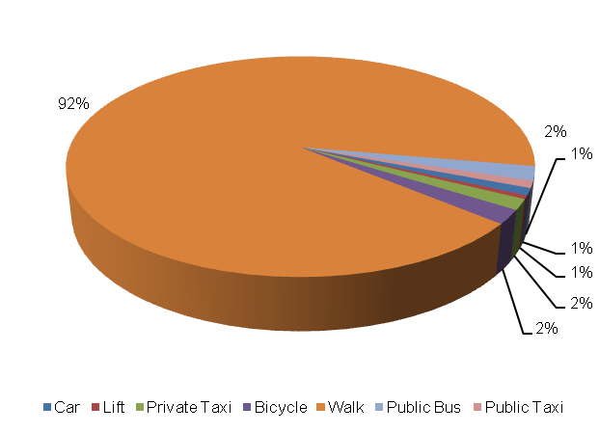
  - Work trips: 78 percent of persons in shaking walk to work whilst 7 percent make use of private taxis. Other modes of transport used for work trips are public buses (6%), cars (3%) and bicycles (2%). Wheel carts (1%) and private bakkies (1%) are among the least used modes of transport to work.
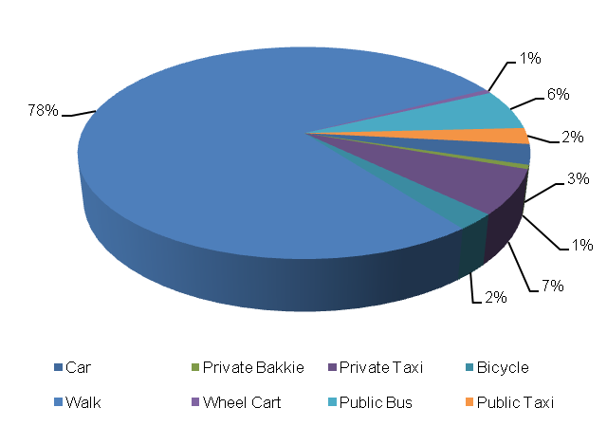

  - Other Household Week Travelling: Similar to the work trips, the majority of other household week trips are undertaken on foot (78%) with private taxis being the second most used mode of transport for other week trips (8%). Other household week trips are embarked on by bus (6%), bicycle (3%), public taxi (2%) and by car (2%).

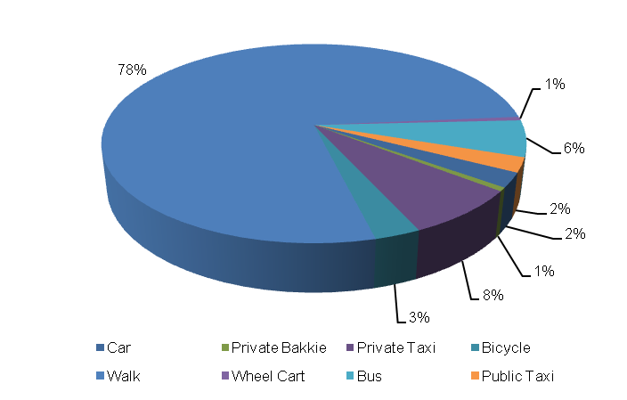

  - Household Weekend Travelling: The majority of household weekend trips are undertaken on foot (44%). Other modes used for weekend trips are private bakkies (19%), lifts (15%) and public taxis (15%). Buses (2%), public bakkies (2%) and private bakkies (2%) are among some of the least used modes of transport in Shakung.
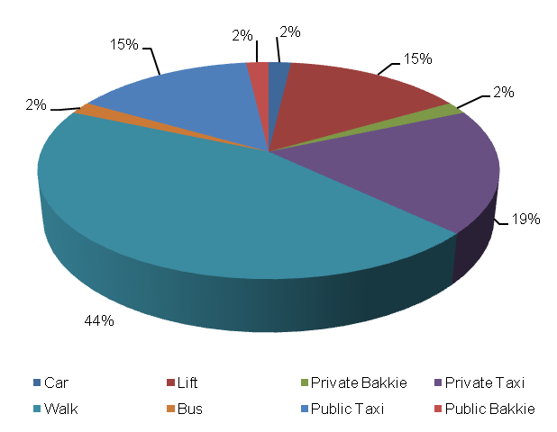

- Mode Preference
The next section examines the transport modes preferred by travellers in Shakung.

  - Educational Trips: The majority of scholars prefer walking to school (81%) whilst others prefer using donkey carts (6%). Other preferred modes of transport used to for educational trips include taking the shova-kalula (5%), riding a bicycle (3%) and riding a horse or donkey (2%).
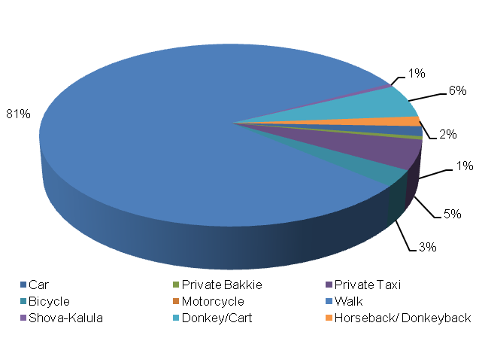

  - Work Trips: The majority of income-earners prefer to walk to work (78%). Other preferred modes or travel to work include private taxi (8%), bicycle (6%), train (3%) and car (2%).

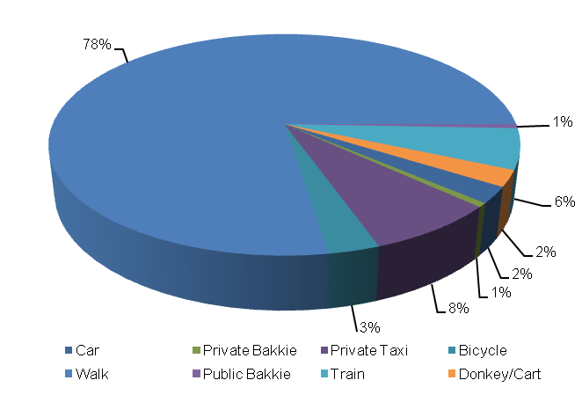

- Identified Transport Usage
The Shakung community waits longer for public transport on Tuesdays and Wednesdays. Other days where members of household find it difficult to travel are Mondays, Thursdays and Fridays although they travel with ease in Saturdays and Sundays. The Friday that falls on the end of the month is also a difficult period for travelling.
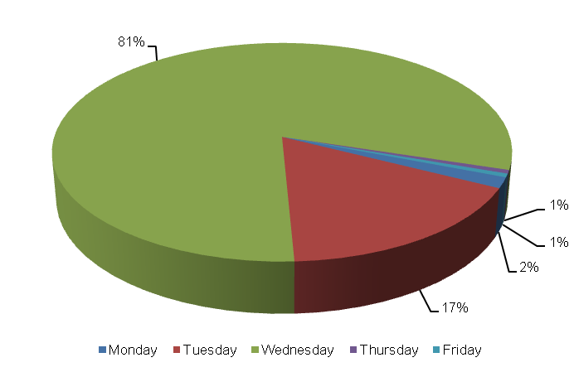

- Identified Transport Issues
The only challenge experienced by members of the Shakung community with regards to travelling is not being able to afford public transport.

- Detailed Project Description
The main goal of the project is to the upgrading of D4177 & D4176, with NMT infrastructure, from the R37 to the settlement to address the needs of the community at large
The objectives of the project will be the following:
- Community consultations
- Status quo investigation of existing transport infra-structure
- Development of concept surfacing solutions/options
- Topographical survey of road reserve
- Preliminary design
- Detailed design and Tender documentation
- Construction of facilities
- Maintenance of facilities post construction

The above steps are outlined in detail below:
  - Community Liaison
Community participation needs to form the backbone of the entire implementation process. The community, as the end users, need to be consulted regarding the preferred solutions from a range of concepts that will arise from the preliminary investigations and concept development stage of the project. There will also be need to liaise with individuals whose property may be affected by the project. The project therefore requires a project steering committee that includes all stakeholders, i.e. the community, ward committees, local municipality, district municipality, etc.

  - Status Quo Investigations
The first task to be undertaken under the project shall be a reconnaissance of the existing road to Shakung Settlement, via Ga Kgwete village. The reconnaissance shall entail condition survey of the roadways together with an assessment of the stormwater tendencies around the infra-structure.

  - Planning and Development of Concept Solutions
Emanating from the results of the above stage, together with any other areas explored as directed by consultation with the community, a number of concepts shall be developed that would be presented to all stakeholders to select the option that would satisfy all. The basic option shall be taken as the tarring of the road from the R37 into the heart of Shakung village. The assumed length of the road is 15 km up to the R37. Various other possibilities will also be explored.
In conjunction with the development of concepts the municipality, Road Agency Limpopo and Limpopo Roads and Transport shall be approached to determine their requirements with regard to the implementation of the project. Some of the salient issues would be the MIG requirements, the reporting requirements and any other aspects that would have to be incorporated into the project plan.
  - Preliminary Design
Subsequent to the selection of the preferred concept a topographical survey of the road reserves needs to be undertaken in order to produce a digital terrain model (DTM) of the areas. A preliminary design needs to also be undertaken to indicate the existing and modified horizontal layout of the routes together with the vertical alignment in order to determine the bulk earthworks that would be involved. The design needs to adhere to the following basic design requirements:
- providing both horizontal and vertical alignments that adhere to the requirements of the Design Manuals i.e. TRH17 and the Red Book;
- exploration of innovative solutions;
- ensuring that required drainage structures can be accommodated by the proposed alignments;

Preliminary design needs to be concluded by the prepared and submitted of a Preliminary Design Report to the Employer for approval.

  - Detailed Design and Documentation
The purpose of detailed design is to optimize the horizontal and vertical alignments and also address stormwater drainage of the proposed infrastructure. Pavement design should be undertaken in accordance with TRH14. In this stage borrow pits need to be identified, explored and tested if required in order to raise the existing low road levels. All relevant mining permits and environmental impact applications should also be undertaken at this stage. A design report needs to be submitted which should include drawings and updated cost estimates. This stage should culminate with the compilation of tender documents and advertising of the project for contractors to tender.
The tender process and tender evaluation would follow and the preferred Contractor would be recommended for the Employer to appoint. Contract Documents would be compiled that would govern the contract.
  - Construction
Construction of the works would aim to create as much employment as possible for the local community. It would therefore be desirable that the works is undertaken under Labour Intensive Construction mode. The Contractor would submit a construction programme which he would follow in implementing the works. Supervision of construction would provide the Employer with an assurance that the works delivered by the Contractor comply with the requirements set out in the Contract Documents to ensure return on investment. The construction stage would culminate with the handing over of the finished facilities to the community for use. A project close out report would be submitted to outline all achievements and challenges experienced in the project.

  - Transport Infrastructure Maintenance
The maintenance of the transport infrastructure envisaged in Tubatse will be crucial for the provision of proficient and valuable public transport in the settlement. During Phase 3 an Evaluation and Monitoring System will be developed to ensure effective management of transport infrastructure in the settlement.

- Value-Add of the Project to the Community
The following constitute the value added by the project to Tubatse Community:
- Provision of adequate road transport facilities;
- Promote the use of non-motorised transport by providing adequate walkway on the access road;
- Minimise conflict between pedestrians and vehicles;
- Reduce accidents involving pedestrians and vehicles.

- First-Order Cost Estimates
The first-order cost estimate (VAT excluded) for each component of the project is as follows:
- Community liaison (included in the following components)
- Preliminary Investigations and Surveys R 250, 000
- Planning, Design & Tender Documentation R 600, 000
- Construction Contract R 90, 000, 000
- Construction Supervision R 18, 000, 000
- Other: EIA, OHS R 550, 000
The total first-order cost estimate is R 109 400 000.
It should be noted that the above costing assumes that essential corrective earthworks would be applied to the road prior to surfacing. Furthermore, possible sources of funding for this project would be MIG funding from the municipality which would require that the project is listed in their IDP. Other funding can be sourced from the EPWP budget if the project is packaged for that mode of construction.
- Project Duration
The following timeframes are envisaged per component:
- Planning, Design & Tender Documentation 7 months
- Construction Contract 12 months

- First-Order Risk Assessment
The only first-order risks identified is the availability of MIG funding for the projects.

- Opportunity for SMME Involvement
SMME can be offered sub-contracts on portions of the works.

