- Project Name
Asphalt surfacing of D3910 from P277/1to Tshikondeni mine

- Project Type
This type of project is classified as an Upgrading of Road Infrastructure Project

- Project Location
The project is in Bende Mutale a village under Mutale Local Municipality within Vhembe District Municipality

- Broader Context
The project was derived from the findings of the Limpopo Rural Strategy status quo report. The Phase 1 of the Compilation of the Rural Transport Plan for the Limpopo Province made the following findings with regard to rural transportation in Bende Mutale.

- Village Profile: The average household size is 4.3 persons per household, with children (58%) being the majority of members. The amount of mothers and fathers is also significant, with 23% and 17% respectively. Extended family members account for 3% per household.

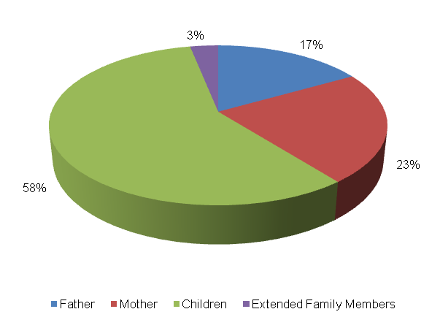

Bicycle | Motorbike | Car | Truck Light | Truck Heavy | Tractor | Taxi | Animal-Drawn Cart | Horse/  Donkey | Wheel barrow/ Handheld
14 | 15 | 18 | 6 | 2 | 0 | 2 | 5 | 0 | 95
9% | 10% | 11% | 4% | 1% | 0% | 1% | 3% | 0% | 61%
The level of vehicle ownership per household is presented in the table below.

Majority of the households (61%) own a wheel barrow, whilst 11 percent own cars, 10 percent motorbikes and 9 percent of the households in Bende Mutale own bicycles. 4 percent own light trucks and 3 percent of the households own animal drawn carts. The least owned vehicle types by households are taxis (1%) and heavy trucks (0.3%).

The abstract below shows employment status in Bende Mutale. The following observations were made:
- Approximately 30 percent of the persons are unemployed in Bende Mutale;
- Approximately 42 percent of people in Bende Mutale are school going children, with 9 percent being pre-school going children;
- 5 percent of the persons in Bende Mutale are permanently employed whilst 9 percent have conditional employment;
- About 5 percent of the persons in Bende Mutale are pensioners.
- Travelling Patterns: This section presents the travelling patterns in Bende Mutale.

- Educational Trips: Majority of the trips are undertaken by foot (74%). The public bus service (21%) is also widely used for educational trips. An insignificant number of scholars make use of public and private bakkies with 5% and 1% respectively.

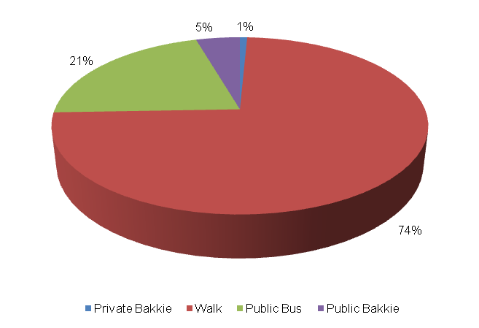
- Work Trips: Majority of work trips are undertaken by cars (50%). Other significant work trips are undertaken by foot (22%), public bakkie (11%) and private bakkie (11%). The least number of work trips are made by public bus service with 6%.

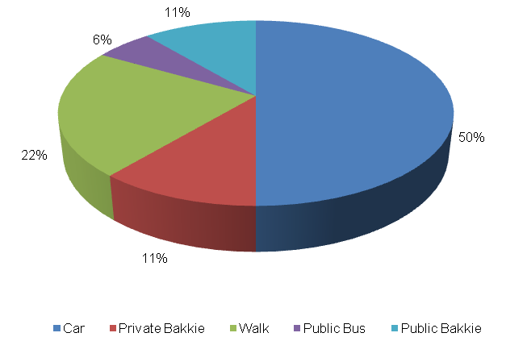
- Other Household Week Travelling: 29 percent of other members of the households used cars to travel to their destination during the week. Other significant modes used for weekday travel include public bus service (21%), private and public bakkie with 14 percent each respectively. An insignificant number of household members walked (7%) to their destination during the week.

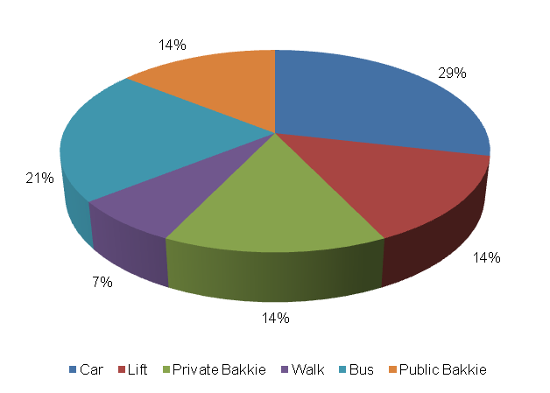

- Household Weekend Travelling: 40 percent of household members used private bakkies to travel to their destinations during the weekend. Other significant modes of transport used for weekend travel include walking with 30%, private taxi (20%), as well as cars 10 percent.

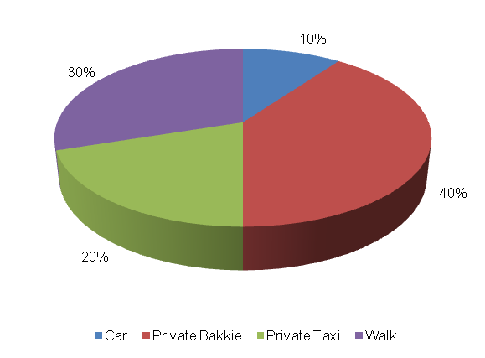
- Mode preference: The next section discusses mode preference of different travellers in Bende Mutale.

- Educational Travel: The majority of scholars prefer to use public bus service to travel to school. Other preferred modes for school trips include walking (18%) and public bakkies (5%).

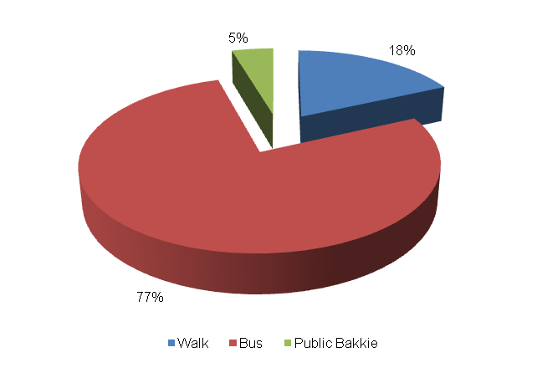
- Work Trips: The majority of workers prefer to use public bus service to travel to work (60%). Other preferred work modes include cars (16%), bicycle (9%), public bakkie (5%), public taxi (5%) as well as walking (5%).

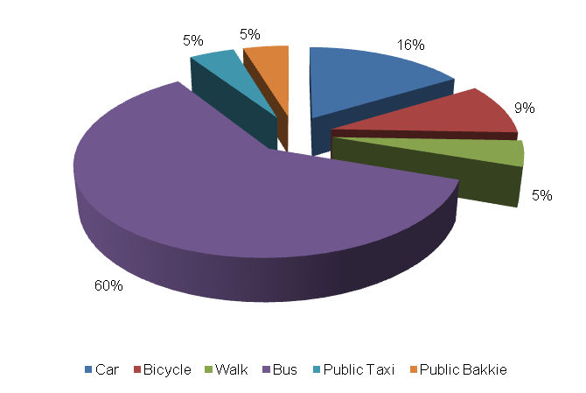
- Identified Transport Usage: The next section presents the usage of transport in Bende Mutale.

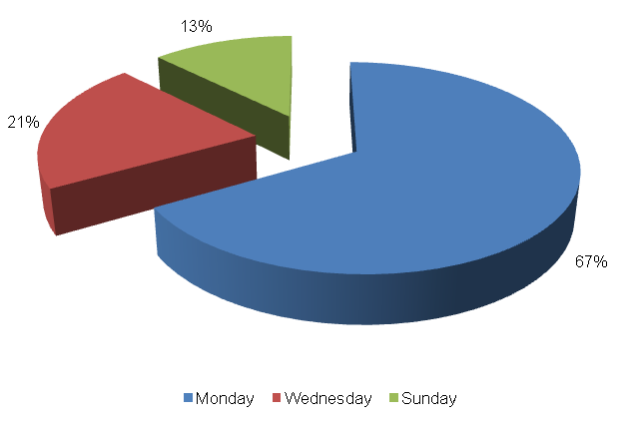
The Bende Mutale community wait longer for public transport on Mondays. Wednesdays and Sundays are also difficult days to travel for the persons of Bende Mutale. The persons of Bende Mutale do not encounter any travel difficulty on Tuesdays, Thursdays, Fridays and Saturdays. The Sunday and Monday that falls on the end of the month are also a difficult periods for travelling. Moreover, Public Holidays, Christmas and Easter, are difficult periods to travel for the Bende Mutale residents.
- Identified Transport Issues
Transport challenges experienced by the Bende Mutale community include:
- Limited public transport services;
- Poor road condition;
- Long waiting periods for public transport;
- Lack of road signs;
- Lack of public transport infrastructure like bus ranks.

- Detailed Project Description
The main goal of the project is the asphalt surfacing of D3910 from P277/1 to Tshikondeni Mine to address the needs of the community at large.
The objectives of the project will be the following:
- Community consultations
- Status quo investigation of existing transport infra-structure
- Development of concept surfacing solutions/options
- Topographical survey of road reserve
- Preliminary design
- Detailed design and Tender documentation
- Construction of facilities
- Maintenance of facilities post construction

The above steps are outlined in detail below:
  - Community Liaison
Community participation needs to form the backbone of the entire implementation process. The community, as the end users, need to be consulted regarding the preferred solutions from a range of concepts that will arise from the preliminary investigations and concept development stage of the project. There will also be need to liaise with individuals whose property may be affected by the project. The project therefore requires a project steering committee that includes all stakeholders, i.e. the community; ward committees, local municipality, district municipality, etc.
  - Status Quo Investigations
The first task to be undertaken under the project shall be a reconnaissance of the existing road to the Tshikondeni Mine. The reconnaissance shall entail condition survey of the roadways together with an assessment of the stormwater tendencies around the infra-structure.
  - Planning and Development of Concept Solutions
Emanating from the results of the above stage, together with any other areas explored as directed by consultation with the community, a number of concepts shall be developed that would be presented to all stakeholders to select the option that would satisfy all. The basic option shall be taken as the tarring of the road from the P277/1 into the heart of Tshikondeni Mine. The assumed length of the road is 10 km up to the P277/1. Various other possibilities will also be explored.
In conjunction with the development of concepts the municipality, Road Agency Limpopo and Limpopo Roads and Transport shall be approached to determine their requirements with regard to the implementation of the project. Some of the salient issues would be the MIG requirements, the reporting requirements and any other aspects that would have to be incorporated into the project plan.
  - Preliminary Design
Subsequent to the selection of the preferred concept a topographical survey of the road reserves needs to be undertaken in order to produce a digital terrain model (DTM) of the areas. A preliminary design needs to also be undertaken to indicate the existing and modified horizontal layout of the routes together with the vertical alignment in order to determine the bulk earthworks that would be involved. The design needs to adhere to the following basic design requirements:
- providing both horizontal and vertical alignments that adhere to the requirements of the Design Manuals i.e. TRH17 and the Red Book;
- exploration of innovative solutions;
- ensuring that required drainage structures can be accommodated by the proposed alignments;

Preliminary design needs to be concluded by the prepared and submitted of a Preliminary Design Report to the Employer for approval.
  - Detailed Design and Documentation
The purpose of detailed design is to optimize the horizontal and vertical alignments and also address stormwater drainage of the proposed infrastructure. Pavement design should be undertaken in accordance with TRH14. In this stage borrow pits need to be identified, explored and tested if required in order to raise the existing low road levels. All relevant mining permits and environmental impact applications should also be undertaken at this stage. A design report needs to be submitted which should include drawings and updated cost estimates. This stage should culminate with the compilation of tender documents and advertising of the project for contractors to tender.
The tender process and tender evaluation would follow and the preferred Contractor would be recommended for the Employer to appoint. Contract Documents would be compiled that would govern the contract.
  - Construction
Construction of the works would aim to create as much employment as possible for the local community. It would therefore be desirable that the works is undertaken under Labour Intensive Construction mode. The Contractor would submit a construction programme which he would follow in implementing the works. Supervision of construction would provide the Employer with an assurance that the works delivered by the Contractor comply with the requirements set out in the Contract Documents to ensure return on investment. he construction stage would culminate with the handing over of the finished facilities to the community for use. A project close out report would be submitted to outline all achievements and challenges experienced in the project.
  - Transport Infrastructure Maintenance
The maintenance of the transport infrastructure envisaged in Bende Mutale will be crucial for the provision of proficient and valuable public transport in the settlement. During Phase 3 an Evaluation and Monitoring System will be developed to ensure effective management of transport infrastructure in the settlement.
- Value-Add of the Project to the Community
The following constitute the value added by the project to Bende Mutale Community:
- Provision of adequate road transport facilities;
- Promote the use of non-motorised transport by providing adequate walkway on the access road;
- Minimise conflict between pedestrians and vehicles;
- Reduce accidents involving pedestrians and vehicles.

- First-Order Cost Estimates
The first-order cost estimate (VAT excluded) for each component of the project is as follows:
- Community liaison (included in the following components)
- Preliminary Investigations and Surveys R 250, 000
- Planning, Design & Tender Documentation R 600, 000
- Construction Contract R 60, 000, 000
- Construction Supervision R 12, 000, 000
- Other: EIA, OHS R 550, 000

The total first-order cost estimate is R 73, 400, 000
It should be noted that the above costing assumes that essential corrective earthworks would be applied to the road prior to surfacing. Furthermore, possible sources of funding for this project would be MIG funding from the municipality which would require that the project is listed in their IDP. Other funding can be sourced from the EPWP budget if the project is packaged for that mode of construction.
- Project Duration
The following timeframes are envisaged per component:
- Planning, Design & Tender Documentation 7 months
- Construction Contract 12 months

- First-Order Risk Assessment
The only first-order risks identified is the availability of MIG funding for the projects.

- Opportunity for SMME Involvement
SMME can be offered sub-contracts on portions of the works.

