- Project Name
Introduction of a scheduled new public transport service amongst villages: Tshituni, Musekhwa, Maranikhwe, DoliDoli and Khomela.

- Project Type
Introduction of Public Transport Services

- Project Location
The project is located in Khomela Local Municipality, which is one of the four Local Municipalities, found in Vhembe District Municipality.

- Broader Context
The project was derived from the findings of the Limpopo Rural Strategy status quo report. The Phase 1 of the Compilation of the Rural Transport Plan for the Limpopo Province made the following findings with regard to rural transportation in Khomela.

- Village Profile
The average household size is 4.9 persons per household, with children (55%) being the majority of members. The amount of mothers is also significant, with 19%. Fathers and extended family members account for 13% per household.

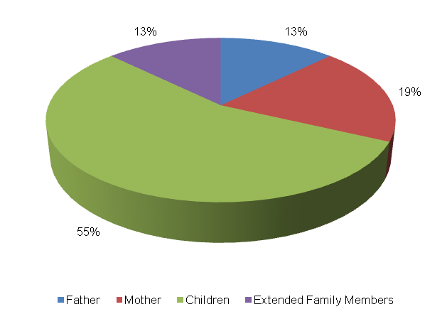

The level of vehicle ownership per household is presented in the table below.

Bicycle | Motorbike | Car | Truck Light | Truck Heavy | Tractor | Taxi | Animal-Drawn | Horse/Donkey | Wheel barrow/ Handheld
8 | 0 | 49 | 0 | 0 | 1 | 4 | 7 | 6 | 67
6% | 0% | 35% | 0% | 0% | 0% | 3% | 5% | 4% | 47%

A majority of the households (47%) own a wheel barrow, whilst (35%) and (6%) of the households in Khomela own cars and bicycles respectively. 5% own animal drawn carts whilst 4% own horses. The least owned vehicle types by households are taxis (3%) and tractors (0.3%).

The abstract below shows employment status in Khomela. The following observations were made:
- The unemployment rate is 24 percent;
- Approximately 26 percent of people in Khomela are school going children, with 5 percent being pre-school going children;
- Approximately 20 percent of the persons in Khomela are permanently employed whilst 21 percent have conditional employment;
- Approximately 5 percent of the persons in Khomela are pensioners.
- Travelling Patterns
This section presents the travelling patterns in Khomela.

- Educational Trips: Majority of the trips are undertaken by foot (55%). The public bus service (38%) is also widely used for educational trips. An insignificant number of scholars make use of public taxis (4%) and public bakkies (2%) to travel to school. Private bakkies (1%) are the least modes used to travel to school.
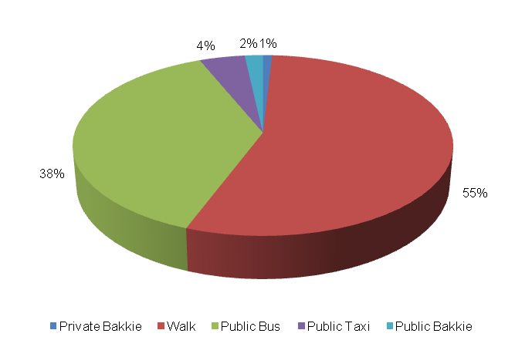
- Work Trips: Majority of work trips are undertaken by cars (37%). Other significant work trips are undertaken by foot (21%), public taxi (21%) and public bus (11%). The least number of work trips are made by private bakkies and private taxis with 5% each respectively.

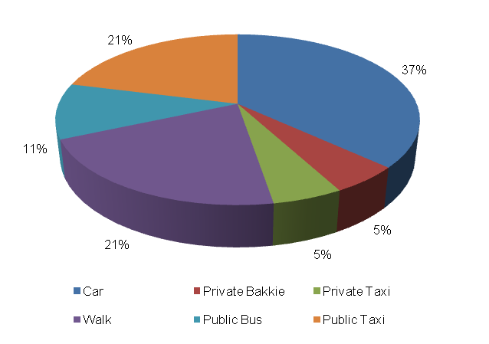
- Other Household Week Travelling: 46 percent of other members of the households walked to their destination during the week. Other significant modes used for weekday travel include public bus service (28%), public taxi (8%) as well as private bakkies (7%). An insignificant number of household members use public bakkies (4%), cars (3%), train (2%) and private taxis (1%).

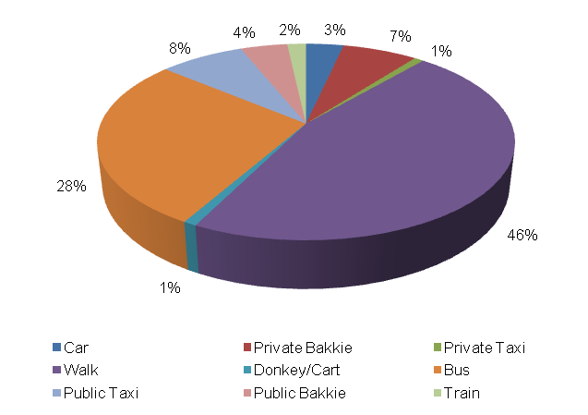

- Household Weekend Travelling: 50 percent of household members walk to their destinations during the weekend. Other significant modes of transport used for weekend travel include public bus service (24%), public bakkie (8%), public taxis (7%) and private bakkies (5%). The least number of households use (3%) and cars (1%) for weekend travel.

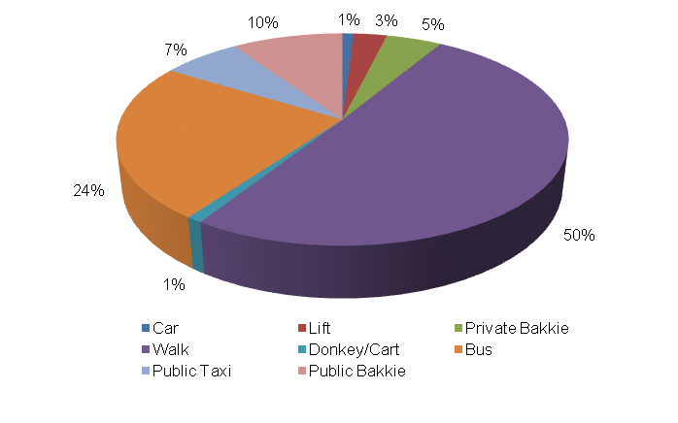
- Mode preference
The next section discusses mode preference of different travellers in Khomela village.
- Educational Travel: The majority of scholars prefer to walk to school (58%). Other preferred modes to travel to school include public bus service (27%) and cars (8%). An insignificant number of scholars prefer public and private taxis with 4% each respectively.

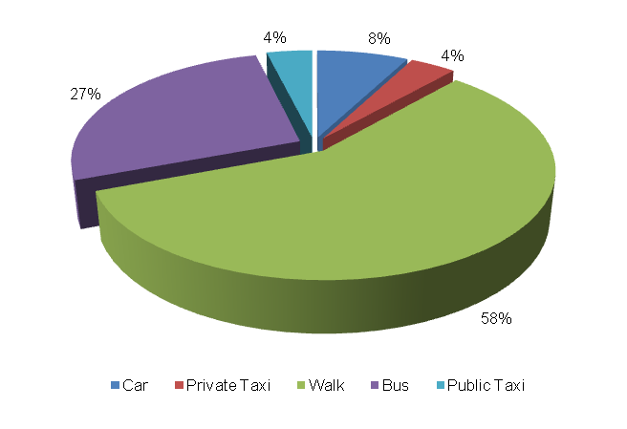
- Work Trips: The majority of income earners prefer to use public taxis to work (43%). Other preferred work modes include cars (13%), public bus (11%), private taxi (11%), public taxi (8%), private bakkie (6%) and train (5%). The least favoured modes to travel to work are lifts (1%) and motorcycles (1%).

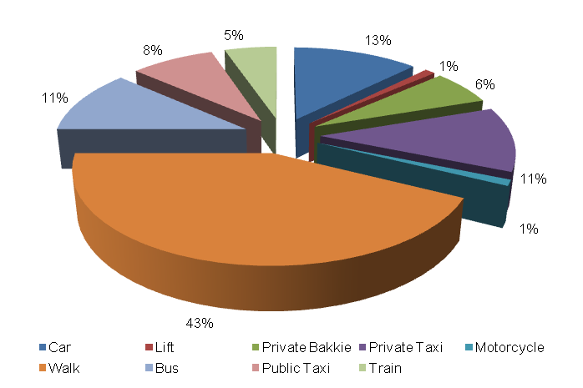
- Identified Transport Usage
The Khomela community wait longer for public transport on Mondays. Fridays, Thursdays and Wednesdays are also difficult days to travel for the persons of Khomela. Households travel with ease on Tuesdays. The persons of Khomela do not encounter any travel difficulty on Saturdays and Sundays. The Friday that falls on the end of the month is also a difficult period for travelling. Moreover, Public Holidays, Christmas and Easter, are difficult periods to travel for the Khomela residents.

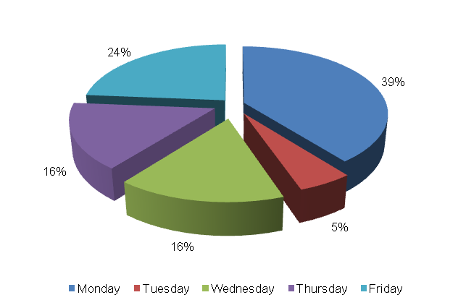
- Identified Transport Issues
This section provides the transport challenges experienced by the Khomela community. The transport challenges include: (1) long waiting periods for public transport; (2) lack of road signs and (3) lack of public transport infrastructure like bus ranks.

- Implication of Findings
The implication of the findings includes:
- The majority of persons residing in Khomela are post-matric students who undertake their educational trips on foot and prefer to use the same mode to travel to educational institutions.
- A significant number of persons are employed in the settlement with 37 percent of them using cars to go travel to their places of employment although most of them prefer using taxis as a means of travelling to work.
- Travelling on foot and travelling by bus are the most significant modes of transport that are used in the settlement.
- The Khomela Community is dissatisfied with lack of road signs; lack of public transport infrastructure; and waiting long for public transport.

Therefore, a detailed feasibility study on the introduction of a scheduled public transport service is seen as an appropriate measure to address some of the challenges facing the community.

- Detailed Project Description
The main goal of the project is to conduct a detailed feasibility study on the introduction of a scheduled 30km public transport service amongst the villages of Tshituni, Musekhwa, Maranikhwe, DoliDoli and Khomela

The objectives of the project will be the following:
- Establishing a Steering Committee for the project;
- Determination of a detailed needs analysis; and
- Developing the Public Transport route specification.

The above-mentioned steps are elaborated on further in the section below.

  - Establishment of a Steering Committee
To ensure that the scheduled public transport service uplifts and serves the needs of the community, a thorough needs-assessment has to be conducted, where all interested and affected parties are involved.

Community participation will be required at the initial stages of the project, which will include the following parties:

- The Local Ward Committee;
- Public Transport Operators;
- Local Municipality representatives;
- District Municipality representatives; and
- Provincial Department of Transport, Roads and Community Safety.

  - Preliminary Needs-Assessment
The establishment of a Steering Committee should be followed by a thourough assessment of the transport needs of Khomela.

Results processed from the household questionnaires will be used to plan passenger transport passenger surveys which should combine counts and interviews for the purposes of collecting comprehensive public transport demand information. Information contained in existing transport plans prepared by the Vhembe District and Makhado Local Municipality has to be collected as well.

  - Primary Data Collection
The primary data collection will comprise of the collection of passenger transport route profiles, passenger transport demand data as well as potential public transport supply data.

  - Detailed Public Transport Service Assessment
The collected documentation, together with the primary data collected should be used to quantify the needs of potential public transport users.
- Public transport route profile;
- Public transport demand;
- Potential public transport supply; and the
- Identification of public transport deficiencies that already exist in the status quo operation or which may occur in the future.

In addition to this, public transport cost coverage needs to be taken into consideration, which will assist in the determination of potential public transport subsidies.

  - Development of a Public Transport Route
The findings of the detailed public transport service assessment should be used to draft a public transport route specification, along with procedures to be followed to ensure that is it successfully implemented.

  - Scheduling Public Transport Monitoring
The monitoring of the scheduled public transport envisaged in Khomela will be crucial for the provision of efficient and valuable public transport in the settlement. During Phase 3, an Evaluation and Monitoring System will be developed to ensure effective monitoring of envisaged public transport services.

- Value-Add of the Project to the Community
The following constitute the value added by the project to the Khomela Community:
- Provision of scheduled public transport that will benefit the community at large; and
- Promote the use of public transport in the entire Limpopo Province.

- First-Order Cost Estimates
- Community liaison (included in the following components)
- Preliminary Needs Assessment R 150, 000
- Primary Data Collection R 650, 000
- Detailed PT Service Assessment R 200, 000
- Development of PT Route Specification R 200, 000

The total first-order cost estimate is R 1 200, 000.

- Project Duration
The project duration is envisaged as follows:
- Establishment of Steering Committee: not accounted for (internal process);
- Preliminary Needs Assessment: 1 month
- Primary Data Collection: 2 months
- Detailed Public Transport Service Assessment: 2 months
- Development of the PT Route Specification: 1 month

- First Order Risk Assessment
The only first-order risk identified is getting total buy-in from all stakeholders, especially transport operators.

- Opportunity for SMME Involvement
SMME can be offered sub-contracts on portions of the works, specifically data collection.

