- Project Name
Rehabilitation of roads within the Maeteletsa village

- Project Type
The project is classified as a Road Upgrade

- Project Location
The project is located in Maeteletsa, a village in Lephalale Local Municipality within the jurisdiction of Waterberg District Municipality.

- Broader Context
This project emanated from the Limpopo Rural Strategy status quo findings whereby a need for the project was identified. Phase 1 of the compilation of the Rural Transport Plan for the Limpopo Province made the following findings with regards to rural transportation in Maeteletsa.

- Village Profile: The average household comprises of 6 people, with children accounting for 50 percent of the household. Mothers and fathers account for 15 percent and 7 percent of households, respectively. 28% of people within each household consist of extended family members.

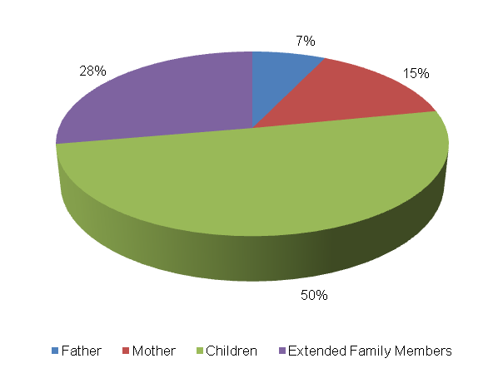

The table below presents the level of vehicle ownership per household.

Bicycle | Motor-bike | Car | Truck (light) | Truck (heavy) | Tractor | Taxi | Animal-drawn cart | Horse/ Donkey | Wheelbarrow/ Hand-held cart | Others
40 | 5 | 15 | 4 | 0 | 1 | 0 | 20 | 67 | 101 | 4
15.8% | 2% | 5.9% | 1.6% | 0% | 0.4% | 0% | 7.9% | 26.5% | 39.9% | 2%

About 40 percent of households in Maeteletsa own wheelbarrows, whilst 27 percent of households own either a horse or a donkey. Additionally, 16 percent of households own bicycles, followed by 8 percent of household which own animal-drawn carts. The least owned vehicles type by households in the Maeteletsa Village are motorbikes (2%), light trucks (2%) and other types of vehicles (2%).

The figure below illustrates the employment status in Maeteletsa. The following observations were made:

  - 40 percent of people living in Maeteletsa are unemployed;
  - Approximately 7 percent of persons in Maeteletsa are employed on a permanent basis and another 7 percent persons are employed on a conditional basis; and
  - Only 3 percent of persons in Maeteletsa are post-high school students, 9 percent are pre-schoolers and 35 percent are scholars.

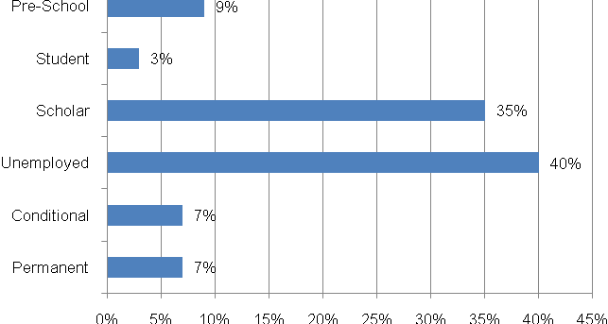

- Travelling Patterns
This section presents the travelling patterns in Maeteletsa.

  - Educational Trips: The majority of educational trips in Maeteletsa are done on foot (99%), with the rest being undertaken through the use of public taxis (1%).

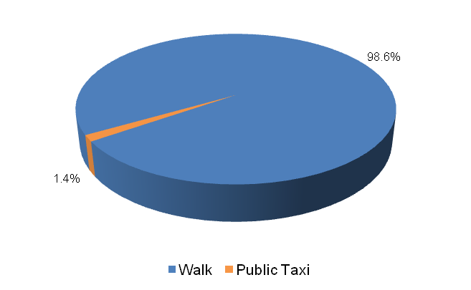

  - Work Trips: The majority of work trips are undertaken on foot (38%), followed by members of households who make use of public buses (23%), private taxis (14%) and public taxis (14%) to travel to work. 9% of households utilize cars to travel to work and the least number of work trips are undertaken by bicycles (2%).

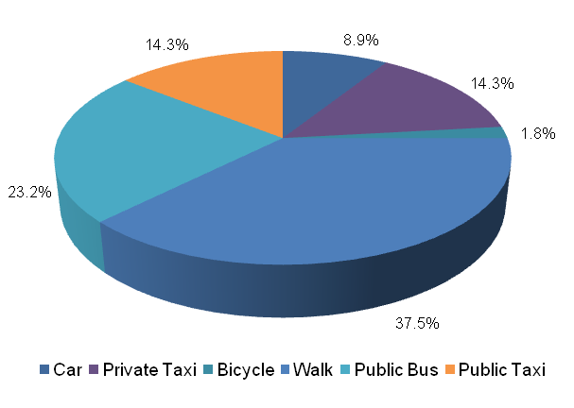

  - Other Household Week Travelling: Approximately 42 percent of other household week trips are undertaken on foot. Other significant trips are undertaken by means of lifts (31%) and through the use of public taxis (13%). 4 percent of other household trips made during the week are undertaken through the use of public bakkies (4%), the train (4%), cars (4%) and public taxis (2%).

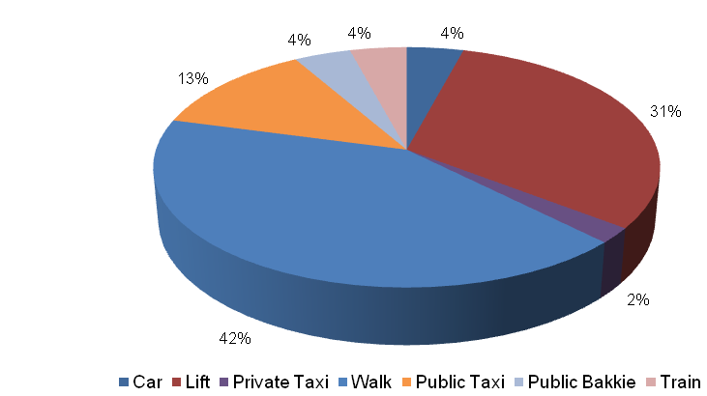

  - Household Weekend Travelling: Most households use lifts for weekend trips (32%). Another popular mode of transport used by members of households when undertaking weekend trips is that of private taxis (26%). About 32% of household weekend trips are undertaken on foot (16%) and by bus (16%).The least used mode of transport is that of the public bakkie (11%).

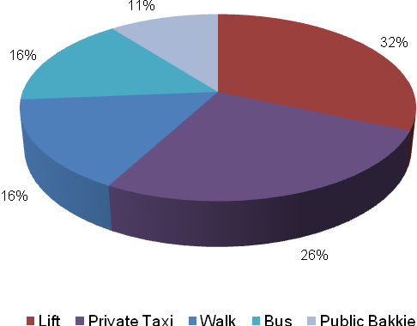

- Mode Preference
The next section discusses the mode preference of different travellers in Maeteletsa.

  - Educational Travel: Most households prefer undertaking educational trips on foot (97%) whereas 3 percent of other households prefer using public taxis.

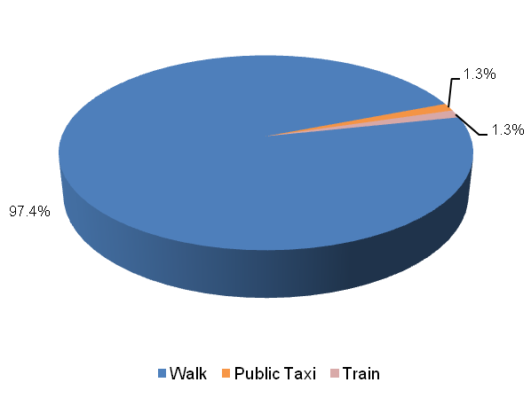

  - Work Trips: A majority of households prefer undertaking work trips by foot (55%). Other significant work trips are undertaken by buses (19%) and through the use of public taxis (14%).

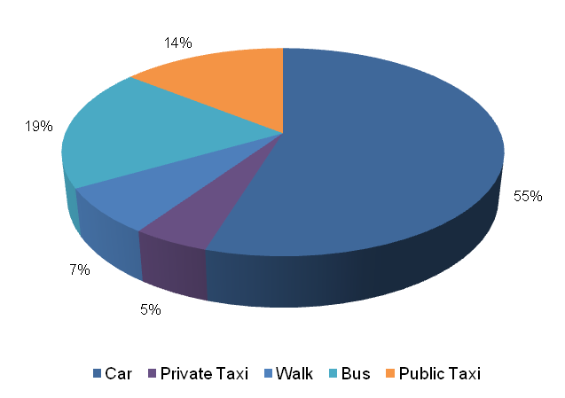

- Identified Transport Usage
The Maeteletsa community waits longer for transport on Mondays. The community of Maeteletsa experience travelling difficulties on a daily basis. Members of households travel with ease on Tuesdays and Thursdays and experience no difficulties travelling on Wednesdays, Friday, Saturdays and Sundays. The Friday that falls on the end of the month is also a difficult period for travelling. Furthermore, Christmas is a difficult period to travel in Maeteletsa.

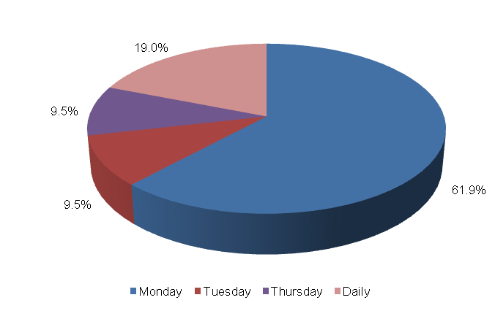

- Identified Transport Issues
This section provides the transport challenges experienced by the Maeteletsa community. These include limited public transport services and long waiting periods for public transport.

- Detailed Project Description
The main goal of the project is to establish the extend of rehabilitate internal roads within the village (assumed 10km) as well the undertaking of road restoration to address transport needs of the community at large
The objectives of the project will be the following:
- Community consultations
- Status quo investigation of existing transport infra-structure
- Development of concept surfacing solutions/options
- Topographical survey of road reserve
- Preliminary design
- Detailed design and Tender documentation
- Construction of facilities
- Maintenance of facilities post construction

The above steps are outlined in detail below:
  - Community Liaison
Community participation needs to form the backbone of the entire implementation process. The community, as the end users, need to be consulted regarding the preferred solutions from a range of concepts that will arise from the preliminary investigations and concept development stage of the project. There will also be need to liaise with individuals whose property may be affected by the project. The project therefore requires a project steering committee that includes all stakeholders, i.e. the community, ward committees, local municipality, district municipality, etc.

  - Status Quo Investigations
The first task to be undertaken under the project shall be a reconnaissance of the internal road network within Maeteletsa. The reconnaissance shall entail condition survey of the roadways together with an assessment of the stormwater tendencies around the infra-structure. Furthermore information that needs to be collated includes (but not limited to): extent of internal roads within Maeteletsa as well as the lengths and widths of the roads;

  - Planning and Development of Concept Solutions
Emanating from the results of the above stage, together with any other areas explored as directed by consultation with the community, a number of concepts shall be developed that would be presented to all stakeholders to select the option that would satisfy all. In conjunction with the development of concepts, the municipality, Road Agency Limpopo and Limpopo Roads and Transport shall be approached to determine their requirements with regard to the implementation of the project. Some of the salient issues would be the MIG requirements, the reporting requirements and any other aspects that would have to be incorporated into the project plan.

  - Preliminary Design
Subsequent to the selection of the preferred concept a topographical survey of the road reserves needs to be undertaken in order to produce a digital terrain model (DTM) of the areas. A preliminary design needs to also be undertaken to indicate the existing and modified horizontal layout of the routes together with the vertical alignment in order to determine the bulk earthworks that would be involved. The design needs to adhere to the following basic design requirements:
- providing both horizontal and vertical alignments that adhere to the requirements of the Design Manuals i.e. TRH17 and the Red Book;
- exploration of innovative solutions;
- ensuring that required drainage structures can be accommodated by the proposed alignments;

Preliminary design needs to be concluded by the prepared and submitted of a Preliminary Design Report to the Employer for approval.

  - Detailed Design and Documentation
The purpose of detailed design is to optimize the horizontal and vertical alignments and also address stormwater drainage of the proposed infrastructure. Pavement design should be undertaken in accordance with TRH14. A design report needs to be submitted which should include drawings and updated cost estimates. This stage should culminate with the compilation of tender documents and advertising of the project for contractors to tender.
The tender process and tender evaluation would follow and the preferred Contractor would be recommended for the Employer to appoint. Contract Documents would be compiled that would govern the contract.

  - Construction
Construction of the works would aim to create as much employment as possible for the local community. It would therefore be desirable that the works is undertaken under Labour Intensive Construction mode. The Contractor would submit a construction programme which he would follow in implementing the works. Supervision of construction would provide the Employer with an assurance that the works delivered by the Contractor comply with the requirements set out in the Contract Documents to ensure return on investment. he construction stage would culminate with the handing over of the finished facilities to the community for use. A project close out report would be submitted to outline all achievements and challenges experienced in the project.

  - Transport Infrastructure Maintenance
The maintenance of the transport infrastructure envisaged in Lemondokop will be crucial for the provision of proficient and valuable public transport in the settlement. During Phase 3 an Evaluation and Monitoring System will be developed to ensure effective management of transport infrastructure in the settlement.

- Value-Add of the Project to the Community
The following constitute the value added by the project to Maeteletsa Community:
- Provision of adequate road transport facilities;
- Promote the use of non-motorised transport by providing adequate walkway on the internal network;
- Minimise conflict between pedestrians and vehicles;
- Reduce accidents involving pedestrians and vehicles.

- First-Order Cost Estimates
The first-order cost estimate (VAT excluded) for each component of the project is as follows:
- Community liaison (included in the following components)
- Preliminary Investigations and Surveys R 250, 000
- Planning, Design & Tender Documentation R 600, 000
- Construction Contract R 5, 000, 000
- Construction Supervision R 1, 000, 000
- Other: EIA, OHS R 550, 000
The total first-order cost estimate is R 7, 400, 000.
It should be noted that the above costing assumes that essential corrective earthworks would be applied to the road prior to surfacing. Furthermore, possible sources of funding for this project would be MIG funding from the municipality which would require that the project is listed in their IDP. Other funding can be sourced from the EPWP budget if the project is packaged for that mode of construction.
- Project Duration
The following timeframes are envisaged per component:
- Planning, Design & Tender Documentation 5 months
- Construction Contract 9 months

- First-Order Risk Assessment
The only first-order risks identified is the availability of MIG funding for the projects.

- Opportunity for SMME Involvement
SMME can be offered sub-contracts on portions of the works.

