- Project Name
Construction of modern public transport facility in Vianna Village

- Project Type
The provision of public transport services

- Project Location
The project is located in Vianna, a village in Mogalakwena Local Municipality within the jurisdiction of Waterberg District Municipality.

- Broader Context
This project emanated from the Limpopo Rural Strategy status quo findings whereby a need for the project was identified.

Phase 1 of the Compilation of the Rural Transport Plan for the Limpopo Province made the following findings with regards to rural transportation in Vianna.

- Village Profile: approximately 50 percent of households comprises of children. Furthermore, 31 percent and 11 percent of households comprises of extended family members and mothers, respectively. Fathers (6%) account for the least amount of persons within households.

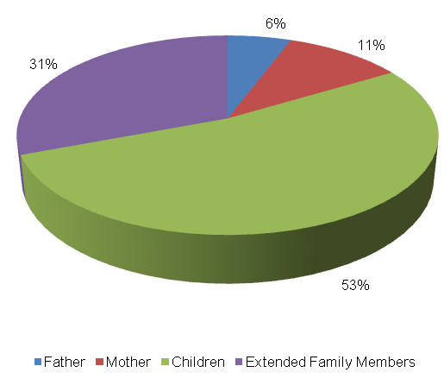

The level of vehicle ownership per household is showed in the table below.
Bicycle | Motor-bike | Car | Truck (light) | Truck (heavy) | Tractor | Taxi | Animal-drawn cart | Horse/ donkey | Wheelbarrow/ Hand-held cart
20 | 3 | 31 | 1 | 0 | 0 | 3 | 23 | 18 | 58
13% | 2% | 20% | 1% | 0% | 0% | 2% | 15% | 11% | 37%

The majority of households in Vianna own wheelbarrows/ handheld carts (37%). Other households own cars (20%) animal-drawn carts (15%), bicycles (13%) and horses / donkeys (11%). Amongst the least owned vehicles are motorbikes (2%), taxis (2%) and light trucks (1%). None of the households in Vianna own heavy trucks and tractors.

The abstract below shows employment status in Vianna. The following observations were made:
  - Unemployment rate in Vianna is 36 percent;
  - 37 percent of persons in Vianna are school-goers, with 5 percent consisting of pre-school children; and
  - 16 percent of the persons in Vianna are employed, 7 percent of which are conditionally employed and 9% have permanent employment.

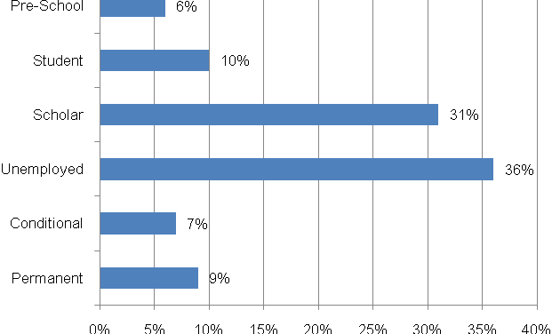

- Travelling Patterns
This section presents the travelling patterns in Vianna.

  - Education Trips: The majority of educational trips are undertaken on foot (99%) whilst others undertake educational trips by means of public buses (1%).

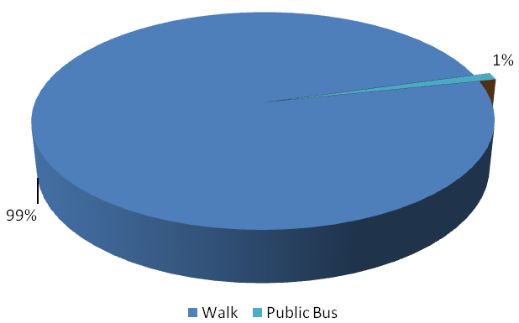

  - Work Trips: The majority of income earners make use of private taxis for work trips (25%) whilst others walk to work (16%). Others make use of cars (14%), lifts (14%), public buses (10%) and public taxis (9%). Motorcycles (1%), bicycles (1%), public bakkie (2%) are amongst the least used for work trips.

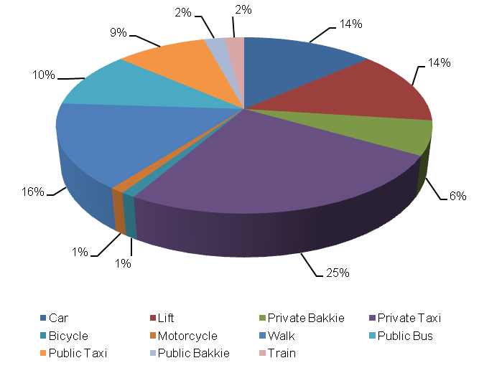

  - Other Household Week Travelling: Private taxi is the most used transport mode for other household week trips (42%) followed by trips undertaken on foot (20%). Members of households also travel through the means of lifts (12%), transport modes used are buses (11%), public taxis (6%), cars (6%) and private taxis (4%)

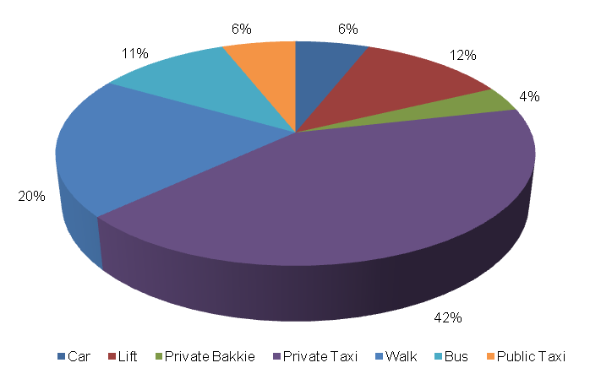

  - Household Weekend Travelling: Most weekend trips are undertaken on foot (44%), followed by those that are undertaken by means of private taxis (19%). Lifts and public taxis each account for 15 percent of transport modes used for household weekend trips whilst private bakkies, cars, buses and public bakkies each account for 2 percent.
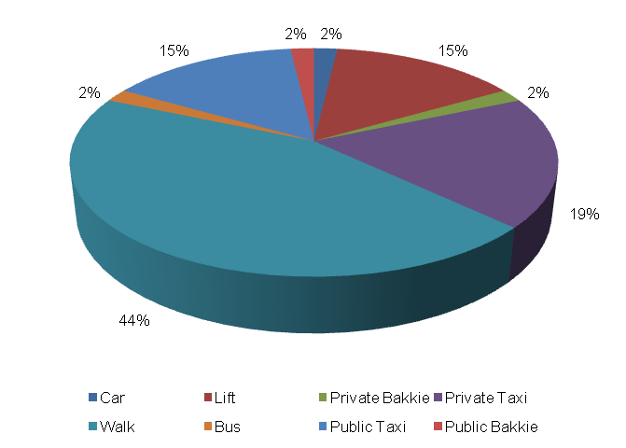
- Mode Preference
The next section discusses the mode preference of the Vianna community.

  - Educational Travel: The majority of persons in Vianna prefer embarking on educational trips on foot (79%). Approximately 9 percent prefer taking the bus whilst 5 percent prefer cycling to school. A marginal 3 percent prefer taking private taxis to school, 2 percent prefer using the Shova-Kalula. Amongst the least preferred are public taxis (1%) and motorcycles (1%).

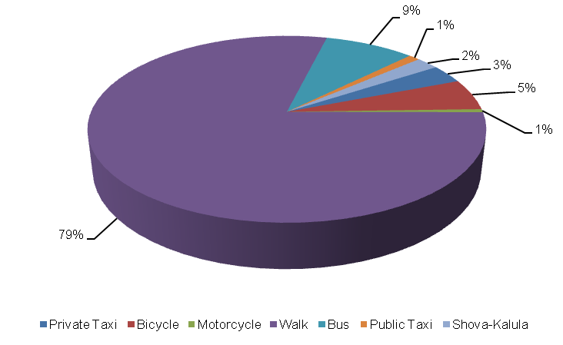

  - Work Trips: The majority of income earners prefer using private taxis to work (29%). Others prefer using walking (17%), cars (16%), buses (12%) and public taxis (8%). Amongst the least preferred are private bakkies (2%), train (2%), public bakkie (1%), motorcycles (1%) and bicycles (1%).
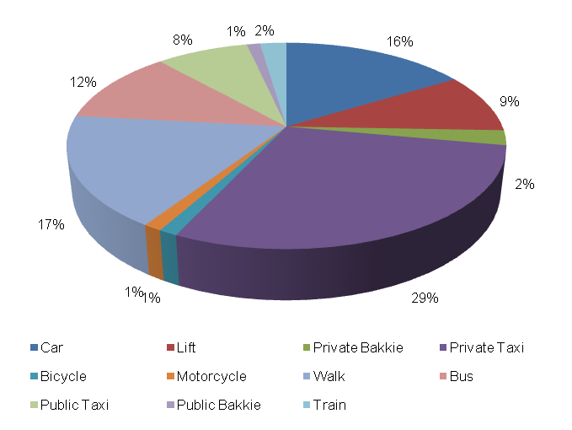

- Identified Transport Usage
Members of the Vianna community experience difficulty travelling with public transport on a daily basis. They wait longer for public transport on Sundays and Saturday more than they do on other days of the week.

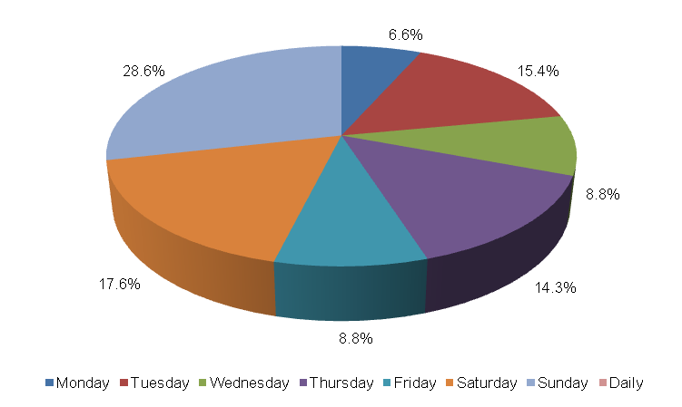

- Identified Transport Issues
Transport challenges experienced by the Vianna community include (1) limited transport services; (2) poor road conditions; and (3) long waiting periods for public transport.

- Detailed Project Description
The main goal of the project is to the construction of modern public transport ranking facilities to address transport needs of the community at large.
The objectives of the project will be the following:
- Community consultations
- Status quo investigation of existing transport infra-structure
- Development of concept surfacing solutions/options
- Topographical survey of road reserve
- Preliminary design of public transport facilities
- Detailed design and Tender documentation
- Construction of facilities
- Maintenance of facilities post construction

The above steps are outlined in detail below:
  - Community Liaison
Community participation needs to form the backbone of the entire implementation process. The community, as the end users, need to be consulted regarding the preferred solutions from a range of concepts that will arise from the preliminary investigations and concept development stage of the project. There will also be need to liaise with individuals whose property may be affected by the project. The project therefore requires a project steering committee that includes all stakeholders, i.e. the community, ward committees, local municipality, district municipality, etc.
  - Status Quo Investigations
The first task to be undertaken under the project shall be a reconnaissance of the public transport facilities within Vianna. The reconnaissance shall entail a determination of needs analysis regarding the public transport facilities needed, the size thereof and together with the preferred location within the village.
  - Planning and Development of Concept Solutions
Emanating from the results of the above stage, together with any other areas explored as directed by consultation with the community, a number of concepts shall be developed that would be presented to all stakeholders to select the option that would satisfy all. In conjunction with the development of concepts the bus and mini bus taxi associations operating in Vianna, Local and District municipality, and Limpopo Roads and Transport shall be approached to determine their requirements with regard to the implementation of the project. Some of the salient issues would be the MIG requirements, the reporting requirements and any other aspects that would have to be incorporated into the project plan.
  - Preliminary Design
Subsequent to the selection of the preferred concept a topographical survey of the road reserves needs to be undertaken in order to produce a digital terrain model (DTM) of the areas. A preliminary design needs to also be undertaken to indicate the existing and modified horizontal layout of the routes together with the vertical alignment in order to determine the bulk earthworks that would be involved. The design needs to adhere to the following basic design requirements:
- providing both horizontal and vertical alignments that adhere to the requirements of the Design Manuals i.e. TRH17 and the Red Book;
- exploration of innovative solutions;
- ensuring that required drainage structures can be accommodated by the proposed alignments;

Preliminary design needs to be concluded by the prepared and submitted of a Preliminary Design Report to the Employer for approval.

  - Detailed Design and Documentation
The purpose of detailed design is to optimize the horizontal and vertical alignments and also address stormwater drainage of the proposed infrastructure. Pavement design should be undertaken in accordance with TRH14. A design report needs to be submitted which should include drawings and updated cost estimates. This stage should culminate with the compilation of tender documents and advertising of the project for contractors to tender.
The tender process and tender evaluation would follow and the preferred Contractor would be recommended for the Employer to appoint. Contract Documents would be compiled that would govern the contract.

  - Construction
Construction of the works would aim to create as much employment as possible for the local community. It would therefore be desirable that the works is undertaken under Labour Intensive Construction mode. The Contractor would submit a construction programme which he would follow in implementing the works. Supervision of construction would provide the Employer with an assurance that the works delivered by the Contractor comply with the requirements set out in the Contract Documents to ensure return on investment. he construction stage would culminate with the handing over of the finished facilities to the community for use. A project close out report would be submitted to outline all achievements and challenges experienced in the project.

  - Transport Infrastructure Maintenance
The maintenance of the transport infrastructure envisaged in Vianna will be crucial for the provision of proficient and valuable public transport in the settlement. During Phase 3 an Evaluation and Monitoring System will be developed to ensure effective management of transport infrastructure in the settlement.

- Value-Add of the Project to the Community
The following constitute the value added by the project to Vianna Community:
- Provision of adequate road transport facilities;
- Promote the use of non-motorised transport by providing adequate walkway on the internal network;
- Minimise conflict between pedestrians and vehicles;
- Reduce accidents involving pedestrians and vehicles.

- First-Order Cost Estimates
The first-order cost estimate (VAT excluded) for each component of the project is as follows:
- Detailed Needs R 100,000
- Development of Transport Infrastructure Master Plan R 150,000
- Community liaison (included in the following components)
- Preliminary Investigations and Surveys R 250, 000
- Planning, Design & Tender Documentation R 600, 000
- Construction Contract R 1, 500, 000
- Construction Supervision R 333, 000
- Other: EIA, OHS R 550, 000
The total first-order cost estimate is R 3, 500, 000.
It should be noted that the above costing assumes that essential corrective earthworks would be applied to the road prior to surfacing. Furthermore, possible sources of funding for this project would be MIG funding from the municipality which would require that the project is listed in their IDP. Other funding can be sourced from the EPWP budget if the project is packaged for that mode of construction.
- Project Duration
The following timeframes are envisaged per component:
- Planning, Design & Tender Documentation 5 months
- Construction Contract 12 months

- First-Order Risk Assessment
The only first-order risks identified is the availability of MIG funding for the projects.

- Opportunity for SMME Involvement
SMME can be offered sub-contracts on portions of the works.

